

**MIT Art, Design and Technology University MIT School of Computing, Pune**

**Department of Information Technology**

**Lab Manual**

**Practical - Web Programming Class - S.Y. (SEM-II), DA**

**Batch - DA-II**

**Anurag Yadav**

**A.Y. 2024 – 2025 (SEM-II)**

File Index page given in the stationary

|  |  |  |  |
| --- | --- | --- | --- |
| **Web Programming**  **SEMESTER – IV** | | | |
| **Course Code:** | 23IT2008 | **Course Credits:** | 02 |
| **Teaching Hours / Week (L:T:P):** | 0:0:4 | **CA Marks:** | 25 |
| **Total Number of Teaching Hours:** |  | **END-SEM Marks:** | 25 |
| **Course Pre-requisites:** | | | |
| **Course Description:**  This course provides a comprehensive introduction to web technology, designed to help students develop a strong foundation in building and managing websites and web applications. The curriculum covers key topics such as HTML, CSS, and JavaScript,PHP, MySQL, which are essential for creating interactive, well-designed web pages. Students will also explore the principles of responsive design, ensuring that web applications are optimized for different devices and screen sizes.  The course dives deeper into server-side technologies, including HTTP, web servers, and databases, allowing students to understand how websites function behind the scenes. Emphasis is placed on practical learning, and students will gain hands-on experience by working on projects that showcase their ability to design, develop, and deploy websites.  By the end of the course, students will be proficient in using modern web technologies to create web applications. They will understand how to handle client-server interactions, manage user data, and implement various web technologies to enhance the functionality of their applications. | | | |
| **Course Learning Objectives:** This course will enable the students to:   1. Understand fundamental concepts of front-end web development. 2. Enable students to create basic web pages incorporating essential elements such as images, hyperlinks, lists, tables, and forms. 3. Teach students how to use CSS to manage fonts, lists, colors, text alignment, and background images for a cohesive and aesthetically pleasing web design. 4. Develop an understanding of JavaScript scopes to manage the visibility and lifetime of variables and functions effectively. 5. Equip students with the skills to implement and handle JavaScript events, enabling enhanced user interactions through event-driven programming. 6. Apply comprehensive knowledge of HTML, CSS, and JavaScript to develop a complete front- end application. Utilize project-based learning to showcase problem-solving skills and creativity in web development projects. 7. Configure server environments with Apache/TOMCAT. 8. Set up a PHP development environment and write basic PHP scripts. 9. Master PHP programming constructs for web development tasks. 10. Create and process HTML forms, and manage MySQL database operations. 11. Develop comprehensive back-end applications using PHP and MySQL. | | | |
| **Course Outcome:** After taking this course, Students will be able to :   1. Apply knowledge of HTML to create the structure of the webpage and CSS to style and layout the elements, making the application visually appealing. 2. Apply comprehensive knowledge of HTML, CSS, and JavaScript to develop a complete front- end application and utilize project-based learning to showcase problem-solving skills and creativity in web development projects. 3. Set up and configure a server environment using tools like Apache or TOMCAT and set up a PHP development environment. Write & execute simple PHP scripts, understanding PHP syntax and basic features, create HTML forms to collect user data and integrate with PHP for processing. 4. Design and develop a back-end application using PHP and MySQL, implementing CRUD | | | |

|  |  |  |
| --- | --- | --- |
| operations to manage data effectively. | | |
| **UNIT – I** | **Introduction to HTML and Cascading Style Sheet** | **09 Hours** |
| Module 1 - Markup Language (HTML): Introduction to HTML, Formatting and Fonts, Commenting Code, Anchors, Backgrounds, Images, Hyperlinks, Lists, Tables, Frames, HTML Forms  Module 2 - CSS: Need for CSS, introduction to CSS, basic syntax and structure, Levels of style sheets, Style specification formats, BOX Model, Selector forms, Property value forms, Font properties, List properties, Color, Alignment of text, Background images | | |
| **Pedagogy** | **ICT Teaching / PowerPoint Presentation and Videos: Use tools like Visual Studio Code (free).**  **Videos:**  [**https://www.coursera.org/learn/html-css-javascript-for-web-developers**](https://www.coursera.org/learn/html-css-javascript-for-web-developers) | |
| **Self-study / Do it yourself /:**  **Practice creating basic HTML pages and enhancing them using CSS.** | |
| **Experiential Learning Topics:**  **Design a simple webpage for coffee shop website** | |
| **PBL - Project Based Learning:**  **Create a multi-page website (e.g., coffee shop website) using HTML and CSS.** | |
|  | | |
| **UNIT – II** | **Front-End Development** | **09 Hours** |
| Module 3 - Overview of JavaScript, including JS in an HTML (Embedded, External), Basic JS syntax, basic interaction with HTML  Module 4 - Core features of JavaScript: Data types, Control Structures, Arrays, Functions and Scopes | | |
| **Pedagogy** | **ICT Teaching / PowerPoint Presentation and Videos: Use tools like Visual Studio Code (free).**  **Videos:** [**https://www.coursera.org/learn/javascript-basics**](https://www.coursera.org/learn/javascript-basics) | |
| **Self-study / Do it yourself /:**  **Solve exercises on JavaScript syntax, control structures, and functions** | |
| **Experiential Learning Topics:**  **Build a web page with interactive elements (e.g., a simple calculator).** | |
| **PBL - Project Based Learning:**  **Develop an interactive webpage that uses JavaScript to validate form inputs or perform basic calculations.** | |
|  | | |
| **UNIT – III** | **Advanced Front-End Development** | **09 Hours** |
| Module 5 - DOM: DOM levels, DOM Objects and their properties and methods, Manipulating DOM Module 6 - JavaScript Events: JavaScript Events, Types of JavaScript Events, Objects in JS, Event Handling | | |
| **Pedagogy** | **ICT Teaching / PowerPoint Presentation and Videos:** [**https://www.coursera.org/learn/building-interactive-web-pages-using-**](https://www.coursera.org/learn/building-interactive-web-pages-using-javascript) | |

|  |  |  |
| --- | --- | --- |
|  | [**javascript**](https://www.coursera.org/learn/building-interactive-web-pages-using-javascript)  **Use tools like Visual Studio Code (free).** | |
| **Self-study / Do it yourself /:**  **Practice exercises on DOM traversal and event handling.** | |
| **Experiential Learning Topics:**  **Add dynamic behavior to a webpage using DOM and events (e.g., a to-do list app).** | |
| **PBL - Project Based Learning:**  **Develop a web page with dynamic content (e.g., a task manager or interactive quiz) using DOM manipulation and event handling.** | |
|  | | |
| **UNIT – IV** | **Server Side Scripting** | **09 Hours** |
| Module 7 - Set up and configure a server environment using tools like Apache or TOMCAT, set up a PHP development environment.  Module 8 -Introduction to PHP: : Introduction to PHP, Server side scripting Vs Client side scripting, Basic Development Concepts (Mixing PHP with HTML), Creating, Writing & Running First PHP Script, PHP syntax, conditions & Loops, Functions, String manipulation, Arrays & Functions, Module 9 - Form handling with HTML and PHP: Designing of Forms using HTML, Form Handling using GET and POST methods of Form | | |
| **Pedagogy** | **ICT Teaching / PowerPoint Presentation and Videos:** [**https://www.coursera.org/learn/web-applications-php**](https://www.coursera.org/learn/web-applications-php)  **Use tools like Visual Studio Code (free), XAMPP/WAMP for PHP server setup, and MySQL Workbench for database management** | |
| **Self-study / Do it yourself /:**  **Practice exercises on form handling and server-side scripting with PHP.** | |
| **Experiential Learning Topics:**  **Create a basic form for data submission and handle it using PHP (e.g., feedback form).** | |
| **PBL - Project Based Learning:**  **Develop a small server-side application (e.g., a contact form with email validation and submission).** | |
|  | | |
| **UNIT – V** | **Working with Databases and Web Application Development** | **09 Hours** |
| Module 10 - Working with databases using MySQL with PHP: MySQL database, create database, create table, primary key with AUTO_INCREMENT setting, Insert Data Into a Database Table, Select Data From a Database Table, Open or close a Connection to the MySQL Server.  Module 11 - Web Application Development (Project): Develop the web application to handle client- server interactions, manage user data, and implement various web technologies to enhance the functionality of their applications. Example: Website for a Coffee Shop | | |
| **Pedagogy** | **ICT Teaching / PowerPoint Presentation and Videos:**  **Use tools like Visual Studio Code (free), XAMPP/WAMP for PHP server setup, and MySQL Workbench for database management**  **Videos:** [**https://www.coursera.org/learn/web-app**](https://www.coursera.org/learn/web-app) | |
| **Self-study / Do it yourself /:** | |

|  |  |
| --- | --- |
|  | **Exercises on creating and manipulating databases using PHP and MySQL.** |
| **Experiential Learning Topics:**  **Create a database and design a webpage to display its data dynamically.** |
| **PBL - Project Based Learning:**  **Develop a fully functional web application (e.g., a Coffee Shop website or e- commerce platform) that integrates database functionality for data management.** |

## Experiment No.1

Problem Statement:

Create the basic structure of an Event Management System website, including the homepage layout with a header, main content area, and footer.

1. Prepare a common project website design and planning document. Consider the following points:
2. Brief information about the project
3. Set goals & deliverables
4. Finalize the modules
5. Define the audience
6. Describe pain points & ideal experience (based on existing systems)
7. Set the visual direction
8. Map out the project structure
9. Plan content for each page
10. Add ideas for content, images & layout

Determine the site structure:

1. Home
2. About
3. Events
4. Testimonials
5. Contact
6. Blog (optional)
7. Collect design elements:
8. Colors
9. Fonts
10. Logos
11. Images/icons
12. These design elements define your brand personality and help customers feel what your brand represents through the use of:
    1. Colors
    2. Fonts and typography
    3. Logos
    4. Images and photos

## Objective:

To design the basic structure of an Event Management System website by planning its layout, content, and visual identity, ensuring it serves event attendees and organizers efficiently.

## Theory:

1. Brief Information about the Project

The project aims to develop a modern, user-friendly, and visually engaging website for an Event Management System, catering to both event attendees and organizers. This platform is intended to simplify the event registration process and enhance the event experience by offering a comprehensive online solution. The website will include detailed event listings, organizer information, a compelling "About Us" section, user testimonials, and a contact platform.

It will be responsive, mobile-friendly, and designed to provide a personalized experience based on user preferences. Features like login/registration, event filters, testimonials, and real-time interaction will offer a professional yet accessible digital interface for event discovery and participation.

2. Goals and Deliverables

Project Goals:

* Develop a fully functional and aesthetically pleasing website for managing and attending events.
* Provide a seamless registration and event discovery process.
* Integrate user authentication for secure login and registration.
* Ensure responsive design for consistent use across devices.
* Promote credibility through user testimonials and easy contact access.
* Cater to different event categories with dedicated filters and event types.

Project Deliverables:

Website Pages:

* Home Page – Welcome users and highlight upcoming or featured events.
* About Page – Share platform vision, history, and team.
* Events Page – Categorized event listings.
* Testimonials Page – User reviews and feedback.
* Contact Page – A form and details to reach the platform team.
* Login Page – Secure login interface.
* Registration Page – New user sign-up form.
* Blog Section (Optional) – Placeholder for news or event updates.

Core Features:

* Common header and footer with navigation.
* Secure login/registration system.
* Responsive and mobile-friendly design.
* Use of optimized fonts, icons, and color schemes.
* Scalable structure for future back-end functionality.

3. Finalized Modules of the Project

The website is modularly structured for maintainability and scalability. Each module corresponds to a key functional section.

1. Home Page Module

* Purpose: Entry point for users
* Key Features:
  + Hero image/banner with CTA (e.g., “Explore Events”, “Register Now”)
  + Highlights of upcoming or popular events
  + Navigation to other pages
  + Footer with quick links and contact details

2. About Page Module

* Purpose: Build trust and transparency
* Key Features:
  + Overview of the platform's story and goals
  + Timeline of growth
  + Team and mission statement
  + Visual storytelling

3. Events Page Module

* Purpose: Event discovery and registration
* Key Features:
  + Categorized events (e.g., Cultural, Technical, Workshops)
  + Filters by date, type, location
  + Event cards with title, image, date/time/location, and “Register” button

4. Testimonials Page Module

* Purpose: Showcase user feedback
* Key Features:
  + Carousel/grid of user reviews
  + Option to submit feedback
  + Ratings, profile names

5. Contact Page Module

* Purpose: Enable communication with the platform
* Key Features:
  + Form (Name, Email, Subject, Message)
  + Static contact info
  + Embedded location map (optional)

6. Login Page Module

* Purpose: Secure user access
* Key Features:
  + Input for email/username and password
  + Forgot password link
  + Link to register page
  + Error handling

7. Registration Page Module

* Purpose: Onboard new users
* Key Features:
  + Fields for Full Name, Email, Password
  + Role selection: User / Admin
  + Terms and conditions agreement
  + Validation checks

8. Footer Module

* Purpose: Global accessibility
* Key Features:
  + Social media icons
  + Quick navigation links
  + Contact info and copyright

4. Define the Audience

Different audience groups will use the platform for varied purposes:

a. Students

* Interested in college events, workshops, webinars
* Need mobile-friendly registration
* Prefer quick filters

b. Working Professionals

* Looking for industry events and conferences
* Expect advanced filtering and reminders

c. Cultural Event Goers

* Attend concerts, fests, or expos
* Expect rich visuals and descriptions

d. Event Organizers/Admins

* Need to create/edit/manage event listings
* Require login-based access

e. New Visitors

* First-time users
* Need clear guidance and onboarding

f. Frequent Users

* Expect saved profiles and quick registration
* Wishlist/bookmark options (future feature)

Common Pain Points in Existing Event Systems:

* Confusing layouts and hard navigation
* No event categorization or filters
* Long, complex registration process
* Lack of mobile optimization
* No review system or feedback
* No contact or support info

Ideal Experience:

* Clean UI, sticky navbar, smooth navigation
* Event categories and smart filters
* Short and secure registration form
* Fully mobile responsive design
* Embedded testimonial module
* Easily accessible support and FAQs

6. Visual Direction

Design Goals:

* Modern, minimal, responsive
* Friendly for all age groups
* Professional yet vibrant

Color Palette:

| Color Name | Hex Code | Usage |
| --- | --- | --- |
| Sky Blue | #2E86C1 | Headers, buttons, accents |
| Sunshine | #F4D03F | Call-to-action, highlights |
| Light Gray | #F8F9F9 | Background, neutral zones |
| Dark Gray | #1C2833 | Text, footers |

Typography:

* Headings: Poppins – modern and clean
* Body Text: Open Sans – readable and smooth

Logo:

* Calendar + Checkmark symbol
* Clean, flat design style

Images:

* High-quality event photos
* Icons for categories (calendar, microphone, etc.)

7. Map out the Project Structure

pgsql

CopyEdit

event_mgmt_website/

│

├── index.html

├── about.html

├── events.html

├── testimonials.html

├── contact.html

├── login.html

├── register.html

│

├── assets/

│ ├── css/

│ │ └── style.css

│ ├── js/

│ │ └── main.js

│ ├── images/

│ ├── banners/

│ ├── logos/

│ ├── icons/

│

└── README.md

## Visual Design Ideas for All Pages:

Colors:

* Vibrant Modern Palette:  
  Use a lively and engaging color scheme including sky blue (#2E86C1), sunshine yellow (#F4D03F), and cool gray (#F8F9F9) to create a professional and energetic look. These colors communicate enthusiasm and reliability, aligning with the dynamic nature of event discovery and participation.
* Highlight Color:  
  Use a deep navy or royal blue (#1C2833) for critical call-to-action (CTA) buttons, links, and key navigation areas like “Register Now” or “Join Event.” This strong accent brings focus and clarity to important user actions while maintaining accessibility and consistency across the interface.

Fonts & Typography:

* Headers:  
  Use a bold, approachable sans-serif font like Poppins or Raleway for headers. This conveys a clean and modern look, ideal for a technology-driven platform that promotes events across academic, professional, and cultural domains.
* Body Text:  
  Choose Open Sans or Roboto for the main content. These fonts are legible and neutral, ensuring comfortable reading for event descriptions, user testimonials, and other detailed sections.
* Button Text:  
  Use Montserrat Semi-Bold or Poppins Bold for buttons and action labels. These fonts offer high readability and ensure that CTAs like “Register,” “Login,” or “Submit Review” stand out in the UI.

Logos:

* Event Management Logo Concept:  
  A clean and modern logo combining a calendar icon, a checkmark, and possibly a location pin or group of people. The logo should express a sense of planning, participation, and connection. The style should be flat, minimalist, and versatile for both light and dark backgrounds. Optional variations could include a badge version or icon-only version for favicon and mobile branding.
* Color Usage in Logo:  
  Utilize the primary palette (sky blue and navy) with white or light yellow accents for contrast and brand identity. The logo should feel active and welcoming, reflecting the essence of event discovery and community.

Images:

* Dynamic, High-Quality Visuals:  
  Use sharp, realistic photos featuring live events, people networking, conference speakers, and festival scenes. These should convey excitement, interaction, and inclusiveness — the core emotions of successful events. Natural lighting and candid photography will enhance trust and relatability.
* Focus on Event Themes & Atmosphere:  
  Depending on the type of events featured (tech, cultural, academic), include relevant imagery like:
  + People attending seminars or workshops
  + Performances or open-air shows
  + Student group discussions or award ceremonies
* Diverse Visual Representation:  
  Ensure representation across age groups, genders, and event types. Use photos of venues, stage setups, event booths, and registration counters to simulate the full event experience.
* Environmental Context:  
  Where appropriate, show indoor auditoriums, open fields, or hybrid online setups. This helps users visualize participation and makes the interface feel real and situationally grounded

## Page-Specific Content, Images, and Layout Ideas:

1. Home Page

Layout Ideas:

* Header Section:
  + Fixed navigation bar with logo on the left.
  + Navigation links: Home | About | Events | Testimonials | Contact
  + CTA buttons on right: Login | Register
* Hero Section:
  + Full-width background image of a live event or tech conference.
  + Overlay text:

“Your Next Experience Starts Here”  
“Discover events that match your passion”

* + CTA Button: Explore Events
* Featured Events Section:
  + Grid layout showcasing 3–4 featured or trending events.
  + Each event includes:
    - Image
    - Title
    - Date & Time
    - Venue
    - "Register Now" button
* Testimonials Preview:
  + Carousel with 2–3 user reviews.
  + Reviewer names, stars, short quotes.
* Footer:
  + Quick links (Privacy Policy, FAQ, Blog)
  + Social media icons (Instagram, Facebook, LinkedIn)
  + Support email and phone number

Image Ideas:

* Banners from past events
* Close-ups of attendees or speakers
* Icons for categories: Talks | Workshops | Cultural

2. About Page

Layout Ideas:

* Introduction:
  + Paragraph introducing the platform:

“Founded in 2025, Eventify helps people find and register for events they care about — from tech summits to college fests.”

* Our Mission:
  + Bullet list of goals:
    - Make event participation easier
    - Help organizers connect with the right audience
    - Promote cultural, technical, and educational engagement
* Our Journey:
  + Timeline layout:
    - 2023: Concept created
    - 2024: First prototype released
    - 2025: Public launch
* Meet the Team:
  + Grid layout with photos of founders/developers, with names and roles
* Values:
  + Cards/blocks for:
    - Inclusivity
    - Simplicity
    - Community-driven design

Image Ideas:

* Candid team shots
* Timeline graphics
* Icons for mission points

3. Events Page

Layout Ideas:

* Search & Filter Panel:
  + Search bar
  + Filters:
    - Category: Technical, Cultural, Workshop, Seminar, Fest
    - Date picker
    - Location dropdown
* Event Grid Section:
  + Cards with:
    - Banner image
    - Title (e.g., “AI Tech Fest 2025”)
    - Date & Time
    - Venue
    - Short description
    - “Register Now” button
* Sort Options:
  + Drop-down to sort by:
    - Most Recent
    - Popularity
    - Date

Image Ideas:

* Event poster-style images
* Microphone, calendar, and people icons
* Organizers’ logos

4. Testimonials Page

Layout Ideas:

* Testimonial Grid or Carousel:
  + Cards with:
    - Attendee Name & Photo
    - Star Rating (1–5)
    - Short quote (max 100–150 words)
* Featured Testimonial Section:
  + Highlight 1–2 featured reviews from college faculty, student reps, or guest speakers.
* Submit Testimonial Form:
  + Input fields:
    - Name
    - Email
    - Rating
    - Review text box
  + Submit button
* Review Guidelines Section:
  + Short paragraph on content moderation and honesty policies.

Image Ideas:

* Profile avatars or real user photos
* Stars, quote icons
* Decorative dividers or stars

5. Contact Page

Layout Ideas:

* Contact Form Section:
  + Fields:
    - Full Name
    - Email Address
    - Subject
    - Message
* Contact Info Section:
  + Email: support@eventify.com
  + Phone: +91-XXXXXXXXXX
  + Operating Hours: Mon–Fri, 10 AM – 6 PM
* Map Embed (optional):
  + Embed Google Map showing HQ location or example event location
* Social Media Links:
  + Icons with links to:
    - Facebook
    - Instagram
    - Twitter
    - LinkedIn

Image Ideas:

* Flat icons for phone, email, map
* Contact symbols (speech bubble, envelope, location pin)

6. Login Page

Layout Ideas:

* Login Form Section:
  + Input fields:
    - Email / Username
    - Password
  + Submit button: Login
  + Links:
    - “Forgot Password?”
    - “Don’t have an account? Register here.”
* Design Suggestions:
  + Minimalist form in center of page
  + Subtle background image (event venue or abstract)
  + Use hover/active states on buttons

Image Ideas:

* Background of people registering for an event
* Login icons (lock, user avatar)

7. Registration Page

Layout Ideas:

* Signup Form Fields:
  + Full Name
  + Email Address
  + Password
  + Confirm Password
  + Select Role (Radio Buttons: User / Admin)
  + Terms & Conditions checkbox
* CTA Button:  
  Create My Account
* Extra Features:
  + Password strength meter (optional)
  + Newsletter subscription checkbox

Image Ideas:

* Background showing enthusiastic users at an event
* Flat vector icons for form fields

8. Blog / Updates Page (Optional)

Layout Ideas:

* Post Previews:
  + Title, snippet, read more button
  + Tags like “#TechFest”, “#Tips”, “#CampusEvents”
* Popular Posts Sidebar:
  + List of trending posts
* Categories Panel:
  + Buttons: All | Announcements | Tips | Behind the Scenes
* Post Detail View (on click):
  + Title, date, content, author
  + Comments section (future enhancement)

Content Ideas:

* “How to Host a College Event in 7 Days”
* “Eventify Partners with XYZ Campus Fest”
* “Checklist Before You Attend a Conference”

Image Ideas:

* Stock banners, student speaker shots, decorative illustrations

Conclusion

In this experiment, we explored the design and planning phase of a web-based Event Management System, aimed at simplifying the discovery, registration, and promotion of events. Through the design thinking process, we identified user needs, project goals, content structure, and branding elements that align with the core functionalities of such a platform.

## Experiment No.2

**Problem Statement:**

• Create a detailed home page for the Event Management System website, showcasing featured or upcoming events with prominent calls to action and an intuitive layout.

• Create a detailed events page (equivalent to a product/menu page) that lists all available events categorized appropriately by type, such as technical, cultural, academic, and workshops.

• Create a "My Events" or registration cart page that allows users to review and manage the events they have registered for before finalizing their participation.

• Create an About Us page that provides detailed information about the Event Management System platform, including its mission, history, and team members (optional).

• Create a Contact Us page that allows users to easily get in touch with the platform administrators or event organizers through a functional contact form.

• Design and implement an admin/user registration form for the website, allowing new users or organizers to securely sign up and access personalized features.

• Design and implement an admin/user login form that allows returning users and event organizers to access their dashboard securely using valid credentials.

Objective:

To create an Event Management System Webpage using HTML, offering a user-friendly online platform for discovering, registering, and managing events. The website will provide a smooth, responsive experience with an emphasis on user satisfaction, ease of navigation, and a comprehensive range of event categories such as technical workshops, cultural festivals, seminars, and webinars.

Introduction

In today’s digital world, online event platforms are essential for efficient planning, promotion, and participation. This project focuses on developing a responsive and functional event management system where users can browse a variety of events, from academic sessions to public festivals. The website aims to make event registration more accessible while promoting collaboration, networking, and participation in diverse domains.

The project integrates both front-end and back-end concepts to offer a seamless user experience, featuring event listings, a registration system, and user-friendly interactions for both participants and organizers. The implementation will initially be based on HTML and CSS, and can optionally be extended with JavaScript or server-side scripting for future enhancements such as dynamic data handling or admin dashboards.

1. Home Page Features

* Hero section featuring highlights of upcoming or featured events
* Navigation bar for easy access to different sections (e.g., Events, About Us, Contact Us)
* Call-to-action buttons such as “Explore Events” and “Register Now”
* Event previews or user testimonials

Importance:  
The homepage serves as the first impression for users, helping establish platform credibility and encouraging users to explore ongoing and upcoming events. A clean, visually appealing layout increases engagement and encourages registration.

Technologies Used:

* HTML for structure
* CSS for layout and styling
* Optional: CSS animations or JavaScript for interactive elements

2. Events Page Features

* Categorized listings such as:
  + Technical Events, Cultural Events, Webinars, Workshops, Seminars
* Event details include:
  + Event banner image, title, and organizer name
  + Date, time, and location
  + Description and attendee limit
  + “Register” button

UX Enhancements:

* Filter options (by type, date, or location) to improve event discoverability
* Sorting options for newest, most popular, or soonest happening events

Importance:  
A well-structured event catalog allows users to easily browse and find relevant events. Clear presentation of event details improves user experience and increases participation rates.

3. Registration Cart / My Events Page Features

* Display of all registered events with details (event title, date, location)
* Options to cancel or reschedule registration (if allowed)
* Button to view more event details or download tickets

Optional Enhancements:

* Event list persistence using localStorage (retains events after refresh)
* Real-time updates if event slots are filled or changed

Importance:  
This page acts like a cart system, where users can review their selected events. It’s a crucial step before confirming attendance. An intuitive registration management system helps reduce dropouts and encourages users to finalize their participation.

4. About Us Page Contents

* History and background of the platform
* Vision and mission statement
* Founder's message or platform inspiration
* Team introduction with photos and bios (optional)

Importance:  
Building trust is essential, especially for event attendees. The “About Us” page humanizes the platform and assures users that they are registering for legitimate, well-organized events.

5. Contact Page Form Includes

* Full Name
* Email Address
* Subject
* Message

Additional Elements:

* Phone number and support email
* Embedded Google Map (e.g., showing office or event location)
* Social media links (Facebook, Instagram, LinkedIn, etc.)

UX Focus:  
Easy access to customer support and communication channels increases user confidence. A clean contact form and up-to-date support information help users resolve queries and build platform credibility.

6. User/Admin Registration Form Fields

* Full Name
* Email Address or Phone Number
* Password & Confirm Password
* User Type (dropdown or radio buttons for User / Organizer / Admin)

Importance:  
Enabling user and admin registration creates a personalized experience for attendees and organizers. This supports features such as event tracking, dashboards, and secure event posting. It also lays the foundation for a robust backend structure involving event approvals and management.

7. User/Admin Login Form Fields

* Username or Email
* Password
* “Remember Me” checkbox
* “Forgot Password?” link

Security (for future phases):

* Basic input validation
* Password hashing and secure storage
* Two-factor authentication and login rate limiting in production

Access Levels:

* Users: Can browse events, register, view registered events
* Admins/Organizers: Can create and manage event listings, view attendees, analyze participation data

Technological Stack Overview (for future versions)

| Function | Tools (Planned) |
| --- | --- |
| Frontend | HTML, CSS, JavaScript |
| Backend | PHP / Node.js |
| Database | MySQL / MongoDB |
| Authentication | Session Management, JWT |
| Storage | LocalStorage / Server DB |

Sustainability Impact

The event platform contributes to social and environmental sustainability by reducing the need for paper-based invitations, registration forms, and manual scheduling. It promotes digital participation and reduces the carbon footprint associated with offline event planning. By supporting virtual and hybrid events, the system broadens access and encourages community engagement across geographic and socioeconomic boundaries.

Additionally, features such as reusable event templates and digital tickets minimize waste and streamline planning, helping organizers conduct more sustainable, efficient, and impactful events

## Code:

**A. Home page:**

<!DOCTYPE html>

<html lang="en">

<head>

<meta charset="UTF-8" />

<meta name="viewport" content="width=device-width, initial-scale=1.0" />

<title>Eventify - Home</title>

<style>

body {

margin: 0;

font-family: 'Poppins', sans-serif;

background-color: #f8f9f9;

color: #1c2833;

}

header {

background: #2e86c1;

padding: 1rem 2rem;

display: flex;

justify-content: space-between;

align-items: center;

color: white;

}

.logo {

font-size: 1.5rem;

font-weight: bold;

}

.nav-links {

list-style: none;

display: flex;

gap: 1.5rem;

}

.nav-links a {

color: white;

text-decoration: none;

font-weight: 500;

}

.hero {

background: url('https://coxhn.com/wp-content/uploads/2022/12/ways-technology-changing-special-events-industry.png') no-repeat center center;

background-size: cover;

color: white;

text-align: center;

padding: 8rem 2rem;

}

.hero h1 {

font-size: 3rem;

margin-bottom: 1rem;

text-shadow: 2px 2px 5px #000;

}

.hero p {

font-size: 1.25rem;

text-shadow: 1px 1px 3px #000;

}

.btn {

padding: 0.75rem 1.5rem;

background: #f4d03f;

border: none;

color: #1c2833;

font-weight: bold;

cursor: pointer;

border-radius: 5px;

margin-top: 1.5rem;

}

footer {

text-align: center;

padding: 1.5rem;

background: #1c2833;

color: white;

}

</style>

</head>

<body>

<header>

<div class="logo">Eventify</div>

<ul class="nav-links">

<li><a href="index.html">Home</a></li>

<li><a href="events.html">Events</a></li>

<li><a href="about.html">About</a></li>

<li><a href="contact.html">Contact</a></li>

<li><a href="register.html">Register</a></li>

<li><a href="login.html">Login</a></li>

</ul>

</header>

<section class="hero">

<h1>Welcome to Eventify</h1>

<p>Discover and register for exciting events around you!</p>

<a href="events.html" class="btn">Explore Events</a>

</section>

<footer>

<p>&copy; 2025 Eventify. All rights reserved.</p>

</footer>

</body>

</html>

## Output:

A. Index/Home page output:

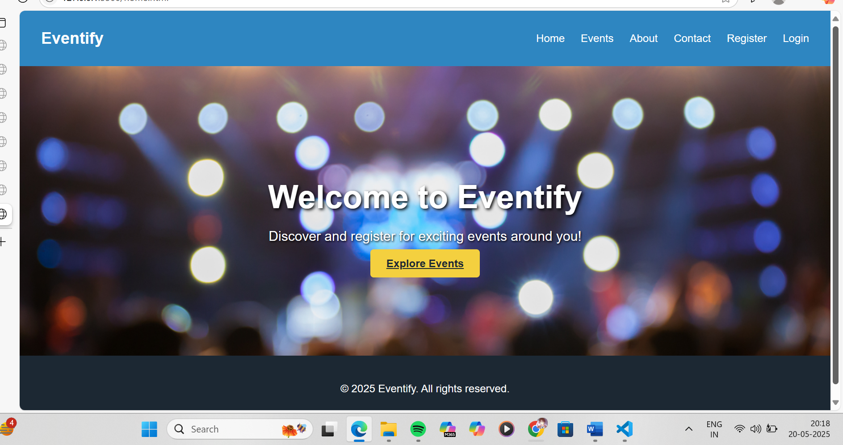

## Code:

**B. Event page:**

Code:

<!DOCTYPE html>

<html lang="en">

<head>

<meta charset="UTF-8" />

<meta name="viewport" content="width=device-width, initial-scale=1.0" />

<title>Eventify - Events</title>

<style>

body {

font-family: 'Poppins', sans-serif;

margin: 0;

background: #f8f9f9;

}

.section {

padding: 3rem 2rem;

}

h2 {

text-align: center;

margin-bottom: 2rem;

color: #2e86c1;

}

.event-grid {

display: grid;

grid-template-columns: repeat(auto-fit, minmax(250px, 1fr));

gap: 2rem;

}

.event-card {

background: white;

padding: 1rem;

border-radius: 10px;

box-shadow: 0 2px 8px rgba(0, 0, 0, 0.1);

text-align: center;

}

.event-card img {

width: 100%;

height: 150px;

object-fit: cover;

border-radius: 8px;

}

.event-card h3 {

margin-top: 1rem;

}

.event-card .btn {

margin-top: 1rem;

background: #2e86c1;

color: white;

padding: 0.5rem 1rem;

border: none;

border-radius: 4px;

cursor: pointer;

}

</style>

</head>

<body>

<section class="section">

<h2>Upcoming Events</h2>

<div class="event-grid">

<div class="event-card">

<img src="https://images.stockcake.com/public/0/8/4/0847c5d0-1732-4f80-9515-c861e73193f4_large/tech-workshop-scene-stockcake.jpg" alt="Tech Workshop" />

<h3>Tech Workshop 2025</h3>

<p>Date: June 20, 2025 | Venue: ABC Auditorium</p>

<button class="btn">Register</button>

</div>

<div class="event-card">

<img src="https://miro.medium.com/v2/resize:fit:1400/0*nOtSwLdswbqUfFSj" alt="AI Conference" />

<h3>AI Conference</h3>

<p>Date: July 5, 2025 | Venue: Convention Center</p>

<button class="btn">Register</button>

</div>

<div class="event-card">

<img src="https://images.unsplash.com/photo-1531058020387-3be344556be6?auto=format&fit=crop&w=700&q=60" alt="Music Fest" />

<h3>Music Fest</h3>

<p>Date: Aug 18, 2025 | Venue: Open Arena</p>

<button class="btn">Register</button>

</div>

</div>

</section>

</body>

</html>

## Output:

**B. Event page output:**

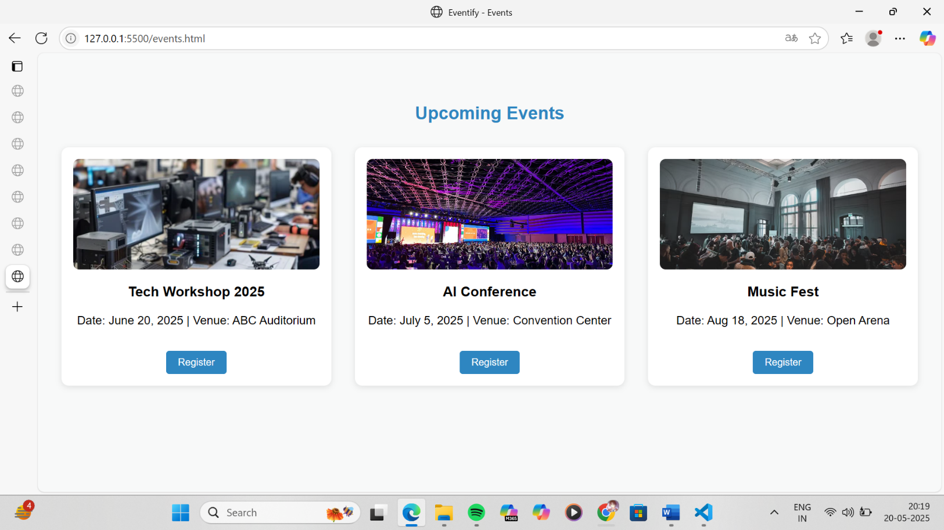

## Code:

**C. about us page: code:**

<!DOCTYPE html>

<html lang="en">

<head>

<meta charset="UTF-8" />

<meta name="viewport" content="width=device-width, initial-scale=1.0" />

<title>Eventify - About Us</title>

<style>

body {

font-family: 'Poppins', sans-serif;

margin: 0;

background-color: #f8f9f9;

color: #1c2833;

}

.section {

padding: 3rem 2rem;

max-width: 800px;

margin: auto;

}

h2 {

text-align: center;

margin-bottom: 2rem;

color: #2e86c1;

}

p {

line-height: 1.6;

margin-bottom: 1.5rem;

}

</style>

</head>

<body>

<section class="section">

<h2>About Us</h2>

<p>Eventify is a modern platform designed to connect people with events that matter. Whether you're a student, professional, or enthusiast, we help you discover workshops, seminars, cultural fests, and online meetups with ease.</p>

<p>Our mission is to simplify the event registration experience while supporting event organizers with smart tools to promote, manage, and grow their audience. From college festivals to global conferences, we aim to be your go-to destination for everything events.</p>

<p>Founded by a group of students and developers passionate about community-building, Eventify believes in the power of events to educate, inspire, and connect people across all walks of life.</p>

</section>

</body>

</html>

## Output:

**C. about us page output:**

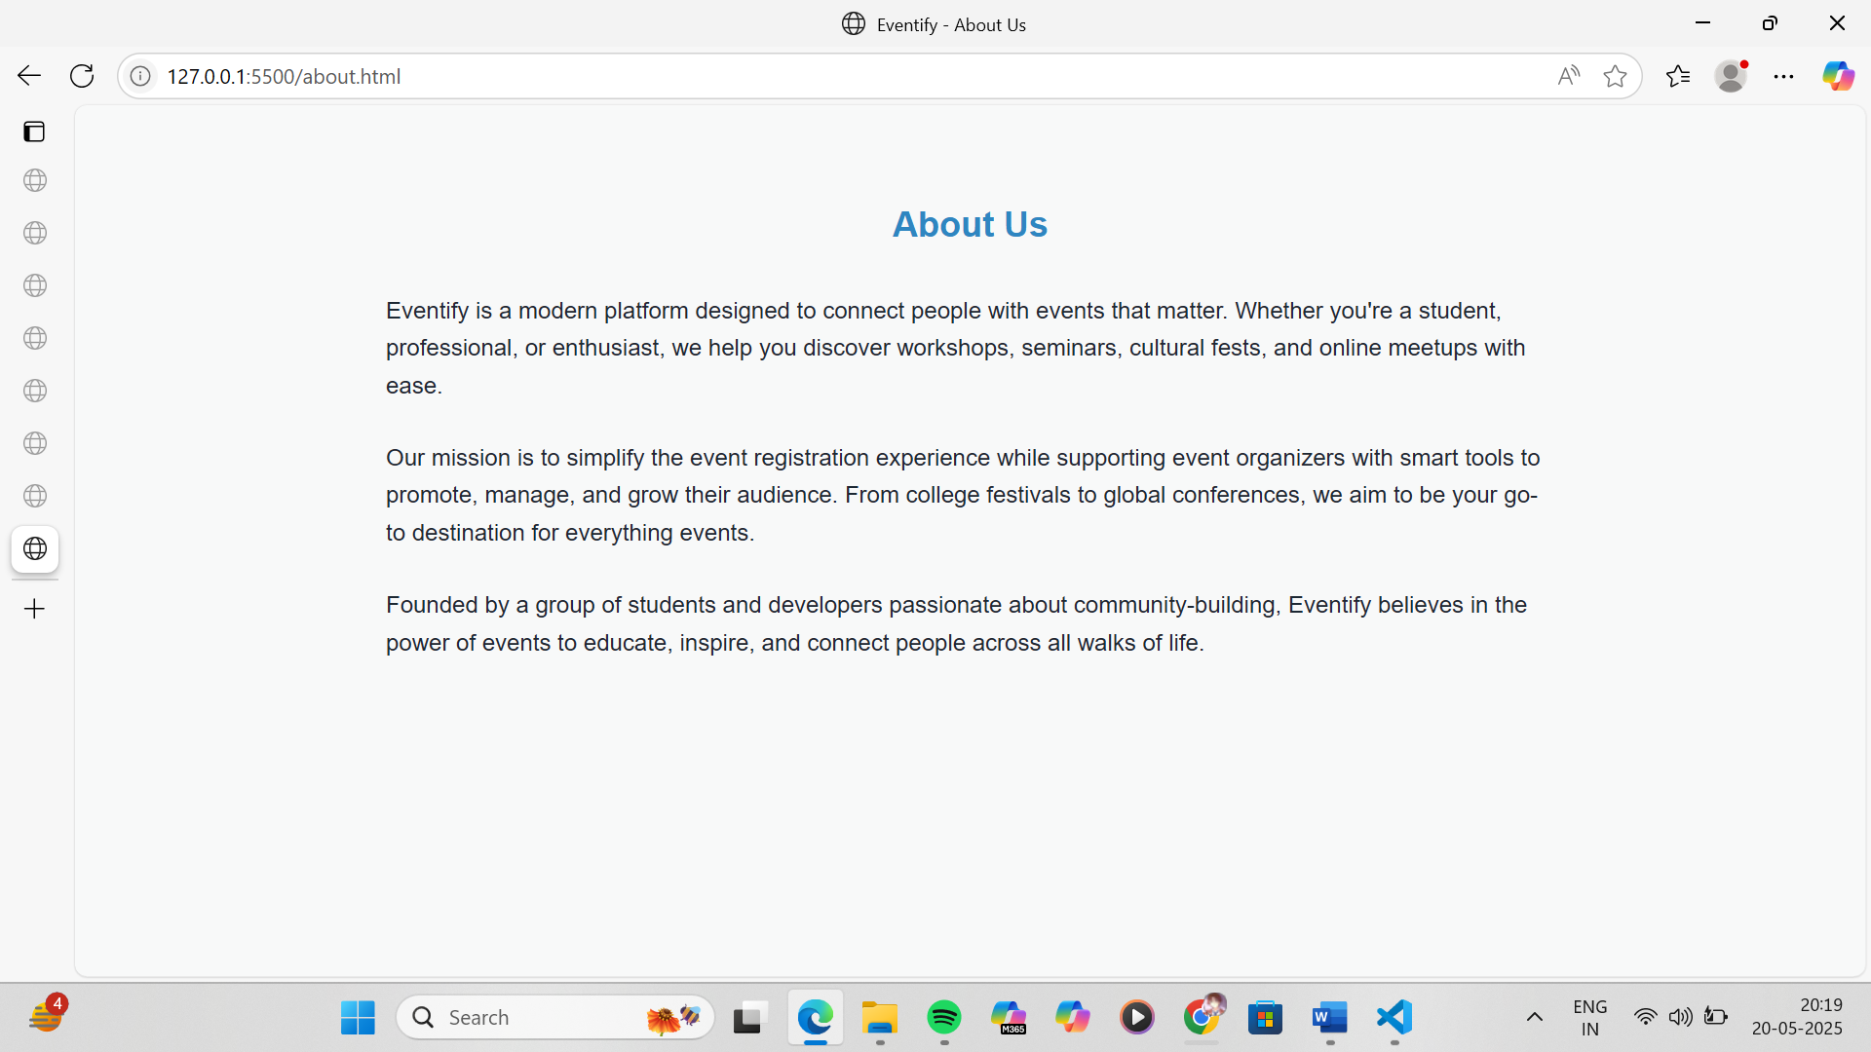

## Code:

**D. contact us page:**

code:

<!DOCTYPE html>

<html lang="en">

<head>

<meta charset="UTF-8" />

<meta name="viewport" content="width=device-width, initial-scale=1.0" />

<title>Eventify - Contact Us</title>

<style>

body {

font-family: 'Poppins', sans-serif;

background-color: #f8f9f9;

margin: 0;

color: #1c2833;

}

.section {

padding: 3rem 2rem;

max-width: 1100px;

margin: auto;

}

h2 {

text-align: center;

color: #2e86c1;

margin-bottom: 2rem;

}

.contact-container {

display: flex;

gap: 2rem;

flex-wrap: wrap;

background: white;

padding: 2rem;

border-radius: 10px;

box-shadow: 0 4px 12px rgba(0, 0, 0, 0.1);

}

.contact-form {

flex: 1;

display: flex;

flex-direction: column;

gap: 1rem;

}

.contact-form input,

.contact-form textarea {

padding: 0.75rem;

border: 1px solid #ccc;

border-radius: 5px;

font-size: 1rem;

}

.contact-form button {

background-color: #f4d03f;

border: none;

padding: 0.75rem;

font-weight: bold;

border-radius: 5px;

color: #1c2833;

cursor: pointer;

}

.contact-info {

flex: 1;

display: flex;

flex-direction: column;

justify-content: center;

padding: 1rem;

}

.contact-info p {

margin: 1rem 0;

font-size: 1rem;

}

.contact-info i {

margin-right: 10px;

color: #2e86c1;

}

.social-links a {

margin-right: 15px;

text-decoration: none;

color: #2e86c1;

font-weight: bold;

}

@media (max-width: 768px) {

.contact-container {

flex-direction: column;

}

}

</style>

<!-- Optional: Font Awesome for icons -->

<script src="https://kit.fontawesome.com/a076d05399.js" crossorigin="anonymous"></script>

</head>

<body>

<section class="section">

<h2>Contact Us</h2>

<div class="contact-container">

<form class="contact-form">

<input type="text" placeholder="Full Name" required />

<input type="email" placeholder="Email Address" required />

<input type="text" placeholder="Subject" required />

<textarea rows="5" placeholder="Your Message" required></textarea>

<button type="submit">Send Message</button>

</form>

<div class="contact-info">

<p><i class="fas fa-envelope"></i> support@eventify.com</p>

<p><i class="fas fa-phone"></i> +91-9876543210</p>

<div class="social-links">

<p><strong>Follow Us:</strong></p>

<a href="#"><i class="fab fa-instagram"></i> Instagram</a>

<a href="#"><i class="fab fa-facebook"></i> Facebook</a>

<a href="#"><i class="fab fa-linkedin"></i> LinkedIn</a>

</div>

</div>

</div>

</section>

</body>

</html>

## Output:

D. contact us page

output:

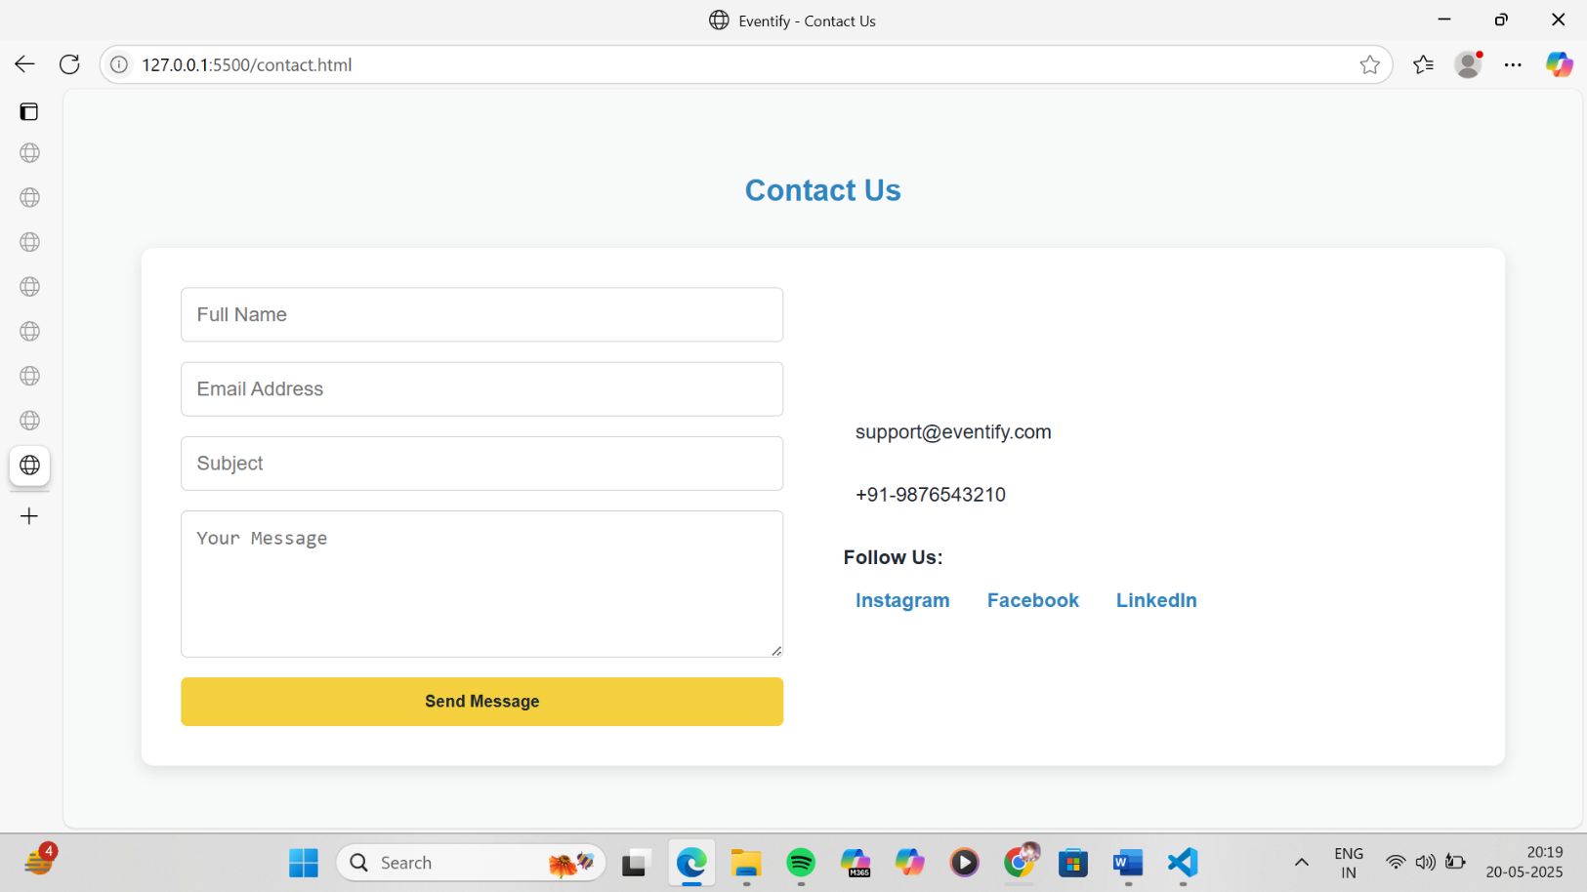

## Code:

E. registration page: code:

<!DOCTYPE html>

<html lang="en">

<head>

  <meta charset="UTF-8" />

  <meta name="viewport" content="width=device-width, initial-scale=1.0" />

  <title>Eventify - Register</title>

  <style>

    body {

      font-family: 'Poppins', sans-serif;

      background-color: #f8f9f9;

      margin: 0;

      color: #1c2833;

    }

    .section {

      padding: 3rem 2rem;

      max-width: 500px;

      margin: auto;

    }

    h2 {

      text-align: center;

      color: #2e86c1;

      margin-bottom: 2rem;

    }

    form {

      display: flex;

      flex-direction: column;

      gap: 1rem;

    }

    input, select {

      padding: 0.75rem;

      border-radius: 5px;

      border: 1px solid #ccc;

      font-size: 1rem;

    }

    button {

      background-color: #f4d03f;

      color: #1c2833;

      padding: 0.75rem;

      border: none;

      border-radius: 5px;

      font-weight: bold;

      cursor: pointer;

    }

  </style>

</head>

<body>

  <section class="section">

    <h2>User Registration</h2>

    <form>

      <input type="text" placeholder="Full Name" required />

      <input type="email" placeholder="Email Address" required />

      <input type="password" placeholder="Password" required />

      <input type="password" placeholder="Confirm Password" required />

      <select required>

        <option value="">Select Role</option>

        <option value="user">User</option>

        <option value="admin">Admin</option>

      </select>

      <button type="submit">Register</button>

    </form>

  </section>

</body>

</html>

## Output:

E. registration page output:

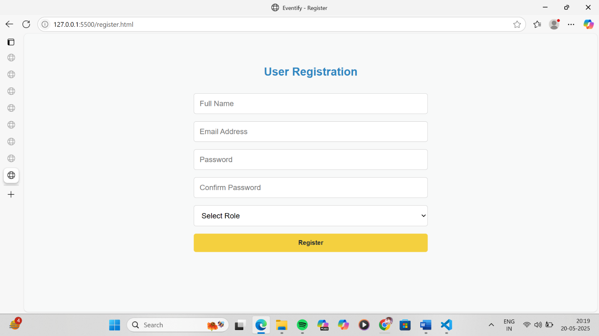

## Code:

F. login page:

code:

<!DOCTYPE html>

<html lang="en">

<head>

<meta charset="UTF-8" />

<meta name="viewport" content="width=device-width, initial-scale=1.0" />

<title>Eventify - Login</title>

<style>

body {

font-family: 'Poppins', sans-serif;

background-color: #f8f9f9;

margin: 0;

color: #1c2833;

}

.section {

padding: 3rem 2rem;

max-width: 500px;

margin: auto;

}

h2 {

text-align: center;

color: #2e86c1;

margin-bottom: 2rem;

}

form {

display: flex;

flex-direction: column;

gap: 1rem;

}

input {

padding: 0.75rem;

border-radius: 5px;

border: 1px solid #ccc;

font-size: 1rem;

}

label {

font-size: 0.9rem;

display: flex;

align-items: center;

gap: 0.5rem;

}

button {

background-color: #f4d03f;

color: #1c2833;

padding: 0.75rem;

border: none;

border-radius: 5px;

font-weight: bold;

cursor: pointer;

}

</style>

</head>

<body>

<section class="section">

<h2>User Login</h2>

<form>

<input type="text" placeholder="Email or Username" required />

<input type="password" placeholder="Password" required />

<label><input type="checkbox" /> Remember Me</label>

<button type="submit">Login</button>

</form>

</section>

</body>

</html>

## Output:

F. login page output:

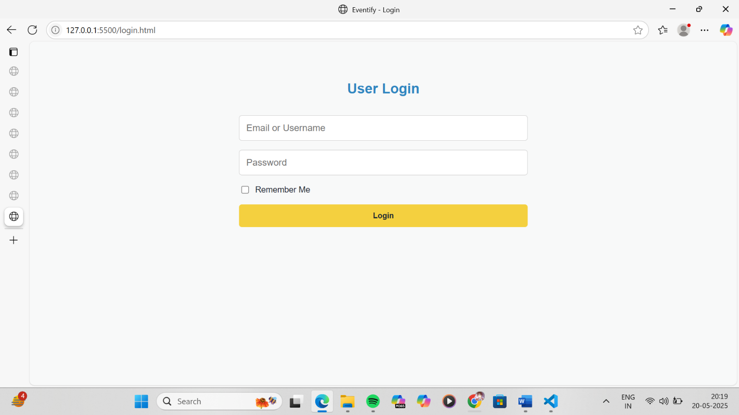

## Conclusion

In this experiment, we created a multi-page Event Management System website using HTML and CSS. It includes a home page, events listing, registration cart, About Us, Contact, and user/admin login and registration forms. The design is responsive and user-friendly, with visual elements like images and forms that enhance usability. This layout provides a strong foundation for adding future features like backend functionality, user management, and dynamic content.

## Experiment No. 3

Problem Statement:

Enhance the layout of the Event Management System website's home page using CSS Grid. Use CSS Grid to organize the featured events section and display event categories (such as Technical, Cultural, Workshops, Webinars, and Seminars) in a structured, visually appealing format with appropriate headings, spacing, category cards, images, descriptions, and registration buttons.

Theory:

CSS Theory for Enhancing the Layout of a Bookstore Website Using CSS Grid

Introduction to CSS Grid

CSS Grid Layout is a powerful two-dimensional layout system that enables developers to create complex and responsive webpage designs. Unlike Flexbox, which is ideal for one-dimensional layouts (either row or column), CSS Grid can manage both rows and columns simultaneously, making it perfect for designing homepage layouts and event category sections.

For an event management system like Eventify, CSS Grid allows developers to:

* Display a wide variety of events in an organized layout
* Uniformly align event cards with images, text, and action buttons
* Design mobile-friendly, flexible pages without needing complex media queries

Why Use CSS Grid for the Event Management Website?

On an event platform, users expect a clear and engaging interface to explore events by type, date, or popularity. CSS Grid makes it easy to:

* Organize event cards neatly in grids (like 2x2 or 3x3)
* Create well-defined sections for “Featured Events,” “Upcoming Workshops,” or “Popular Webinars”
* Ensure that text, images, and register buttons are consistently aligned
* Automatically adapt the layout to different screen sizes (mobile, tablet, desktop)

1. Home Page Layout with CSS Grid

The homepage can be structured using CSS Grid into distinct visual blocks such as:

* Navigation Bar: Full-width with logo and navigation links
* Hero Section: A large banner background or announcement carousel
* Featured Events: 3-column responsive grid showing highlighted events
* Event Categories: Grid layout of different categories (Technical, Cultural, Workshops, etc.)
* Footer: Contact info, social media links, or newsletter subscription

Benefits of this layout:

* Easy to define and separate page sections
* Clean spacing and alignment without float hacks
* Reduces reliance on external frameworks like Bootstrap
* Automatically responsive with modern browser support

2. Events Listing Page Layout Using CSS Grid

Events can be organized into grids by category or type such as:

* Technical Events
* Cultural Programs
* Workshops
* Webinars / Seminars
* Fests & Hackathons

Each event is presented in a card format using Grid:

css

CopyEdit

.events-grid {

display: grid;

grid-template-columns: repeat(auto-fit, minmax(250px, 1fr));

gap: 30px;

padding: 20px;

}

Each event card should include:

* Event Poster or Thumbnail
* Title of Event
* Organizer Name / Date & Time
* Short Description
* Venue or Online Link (if virtual)
* “Register” or “View More” Button

Additional Styling Concepts

* Category Headings: Use bold font, section titles, or colored bars to separate types of events
* Separators: Add horizontal lines or grid gaps between categories
* Hover Effects: Slight elevation of event cards or color change on hover
* Responsive Design: With auto-fit and minmax() functions, Grid automatically adapts layout without needing breakpoints

Mobile Responsiveness with CSS Grid

CSS Grid ensures layouts are responsive by default:

* Event cards stack vertically on small screens
* Buttons remain accessible and large enough to tap
* Text adjusts fluidly for readability
* Overall design remains clean and user-friendly

Summary

CSS Grid is an ideal layout system for structuring an Event Management System. It provides flexibility, control, and ease when designing interfaces for event discovery and registration. Whether displaying featured events or categories, CSS Grid enhances visual appeal, improves interaction, and ensures responsiveness across all devices.

Code:

<!DOCTYPE html>

<html lang="en">

<head>

<meta charset="UTF-8" />

<meta name="viewport" content="width=device-width, initial-scale=1.0" />

<title>Eventify - Home</title>

<style>

body {

margin: 0;

font-family: 'Poppins', sans-serif;

background-color: #f8f9f9;

color: #1c2833;

}

header {

background: #2e86c1;

padding: 1rem 2rem;

display: flex;

justify-content: space-between;

align-items: center;

color: white;

}

.logo {

font-size: 1.5rem;

font-weight: bold;

}

.nav-links {

list-style: none;

display: flex;

gap: 1.5rem;

}

.nav-links a {

color: white;

text-decoration: none;

font-weight: 500;

}

.hero {

background: url('https://images.pexels.com/photos/1313814/pexels-photo-1313814.jpeg?auto=compress&cs=tinysrgb&w=1260&h=750&dpr=2') no-repeat center center;

background-size: cover;

color: white;

text-align: center;

padding: 6rem 2rem;

}

.hero h1 {

font-size: 3rem;

text-shadow: 2px 2px 6px #000;

}

.hero p {

font-size: 1.2rem;

text-shadow: 1px 1px 4px #000;

}

.btn {

background: #f4d03f;

padding: 0.75rem 1.5rem;

border: none;

border-radius: 6px;

font-weight: bold;

margin-top: 1rem;

color: #1c2833;

cursor: pointer;

}

.section {

padding: 3rem 2rem;

max-width: 1200px;

margin: auto;

}

.section h2 {

text-align: center;

margin-bottom: 2rem;

color: #2e86c1;

}

.grid {

display: grid;

grid-template-columns: repeat(auto-fit, minmax(250px, 1fr));

gap: 2rem;

}

.event-card {

background: white;

border-radius: 10px;

padding: 1rem;

box-shadow: 0 2px 8px rgba(0, 0, 0, 0.1);

text-align: center;

transition: transform 0.3s;

}

.event-card:hover {

transform: translateY(-5px);

}

.event-card img {

width: 100%;

height: 150px;

object-fit: cover;

border-radius: 8px;

}

.event-card h3 {

margin-top: 1rem;

}

.event-card p {

font-size: 0.95rem;

}

footer {

text-align: center;

padding: 1.5rem;

background: #1c2833;

color: white;

}

</style>

</head>

<body>

<header>

<div class="logo">Eventify</div>

<ul class="nav-links">

<li><a href="index.html">Home</a></li>

<li><a href="events.html">Events</a></li>

<li><a href="about.html">About</a></li>

<li><a href="contact.html">Contact</a></li>

<li><a href="register.html">Register</a></li>

<li><a href="login.html">Login</a></li>

</ul>

</header>

<section class="hero">

<h1>Welcome to Eventify</h1>

<p>Discover and register for exciting events around you!</p>

<a href="events.html" class="btn">Explore Events</a>

</section>

<section class="section">

<h2>Featured Events</h2>

<div class="grid">

<div class="event-card">

<img src="https://www.cvent.com/sites/default/files/image/2023-11/Event_Technology_Trends-Cvent_CONNECT_2023.jpg" alt="Tech Event" />

<h3>TechFest 2025</h3>

<p>Date: June 22, 2025</p>

<button class="btn">Register</button>

</div>

<div class="event-card">

<img src="https://s3.ap-south-1.amazonaws.com/studyinfocentre.com/media/public/Content/top-10-happening-engineering-college-fests-in-india/fest.jpg" alt="Cultural Night" />

<h3>Cultural Night</h3>

<p>Date: July 15, 2025</p>

<button class="btn">Register</button>

</div>

<div class="event-card">

<img src="https://img.freepik.com/premium-photo/youth-engineering-students-working-electronics-aig41_31965-316801.jpg" alt="Workshop" />

<h3>AI Workshop</h3>

<p>Date: Aug 10, 2025</p>

<button class="btn">Register</button>

</div>

</div>

</section>

<section class="section">

<h2>Event Categories</h2>

<div class="grid">

<div class="event-card">

<h3>Technical Events</h3>

<p>Hackathons, Coding Challenges, Tech Talks</p>

</div>

<div class="event-card">

<h3>Cultural Events</h3>

<p>Music, Dance, Fashion Shows, Theatre</p>

</div>

<div class="event-card">

<h3>Workshops</h3>

<p>Hands-on Training Sessions, Skill Learning</p>

</div>

<div class="event-card">

<h3>Webinars</h3>

<p>Expert Talks, Online Learning & Networking</p>

</div>

<div class="event-card">

<h3>Seminars</h3>

<p>Guest Lectures, Industry Panels, Education</p>

</div>

</div>

</section>

<footer>

<p>&copy; 2025 Eventify. All rights reserved.</p>

</footer>

</body>

</html>

Output:

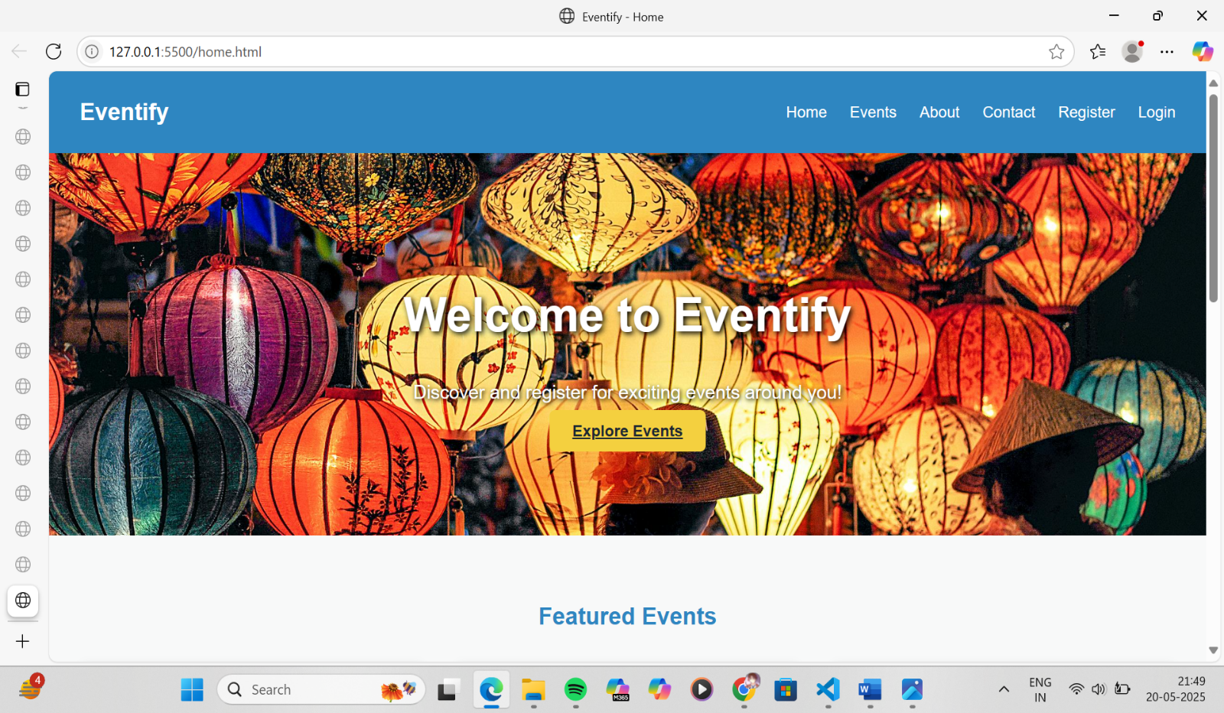

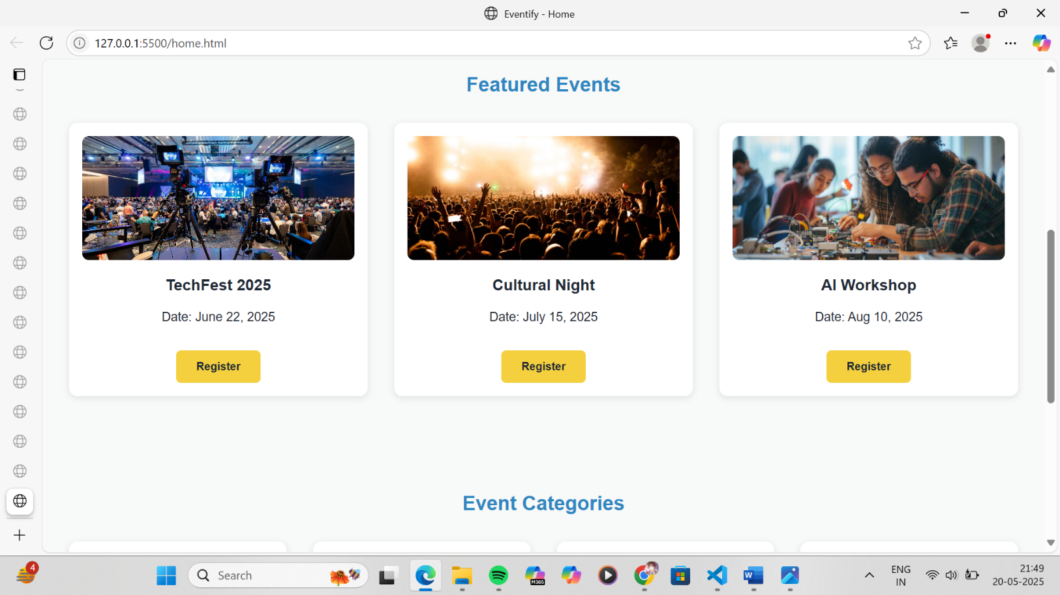

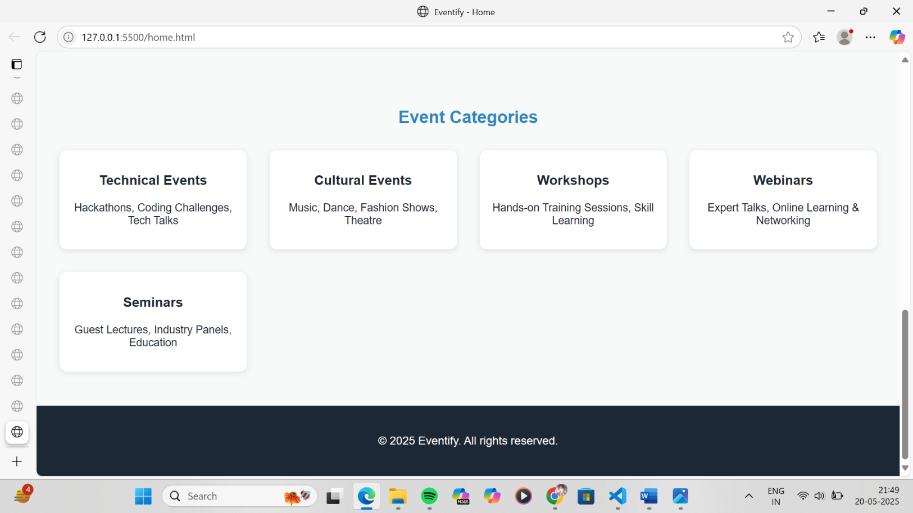

## Conclusion

In this experiment, we enhanced the layout of the Event Management System homepage using **CSS Grid**. A structured and responsive design was implemented to display **featured events** and **event categories** in an organized, user-friendly format. By using CSS Grid, we achieved precise control over alignment, spacing, and responsiveness without the need for complex media queries. This approach improves the visual appeal and usability of the homepage, providing a strong foundation for scalable and modern web design.

**Experiment No.4**

**Problem Statement**

CSS

1. Enhance the cart page to make it user-friendly and visually appealing. Style the cart items with appropriate margins, paddings, and input field styles to provide a seamless shopping experience.
2. Enhance and style the about us page with appropriate margins, paddings, and input field styles.
3. Enhance and style the contact page to make it user-friendly and visually appealing. Style the contact form with appropriate margins, paddings, and input field styles.
4. Enhance and style the admin/user registration form with appropriate margins, paddings, and input field styles.
5. Enhance and style the admin/user login form with appropriate margins, paddings, and input field styles.

CSS Theory: Enhancing and Styling Key Pages in a Second-Hand Gaming Console Website

* 1. Why CSS Styling Matters in E-commerce Websites

When users land on your site, the first thing they notice is how it looks and feels. Clean, well-structured, and visually appealing interfaces significantly improve user trust, navigation, and engagement.

Whether it's a cart, contact form, or registration page, proper styling with CSS margins, paddings, spacing, input design, and color schemes:

* + - Makes the content easier to read
    - Provides a sense of structure and flow
    - Enhances accessibility and user experience (UX)
    - Encourages actions like completing a purchase, registering, or submitting a form

Page-wise CSS Styling Theory

1. Cart Page

The cart page is where users review their selected products before checking out, so it needs to be clear, clean, and action-oriented.

Key Styling Techniques:

* + Add padding around each cart item for separation
  + Use margins to space out product name, quantity input, price, and "remove" button
  + Style input fields (quantity, update buttons) with soft borders and enough clickable area
  + Highlight the total amount with a bold font and distinct background
  + Use consistent font sizes and spacing for price breakdown and tax summaries Result: A structured layout that minimizes confusion and maximizes conversion.

1. About Us Page

This page tells your brand’s story, builds credibility, and helps users connect emotionally with your mission. Key Styling Techniques:

* + Use line height, padding, and justified alignment for readability
  + Add white space between sections like “Our Story,” “Our Mission,” and “Our Team”
  + Use subtle background colors or separator lines for each section
  + Style images (e.g., founders/team) with rounded borders and spacing
  + Highlight values or mission using boxes, grids, or quote-styling Result: A professional and inviting presentation that builds trust.

1. Contact Page

Your contact page should make it effortless for users to reach out for support, queries, or feedback. Key Styling Techniques:

* + Style input fields with equal width, padding, and soft border-radius
  + Use margin-bottom to separate form fields
  + Provide visual feedback on focus (e.g., border color change)
  + Add submit button styling for emphasis (hover effects, background color)
  + Layout the form centrally with balanced padding on all sides

Result: A visually appealing and accessible form that encourages engagement.

1. Admin/User Registration Form

This form is critical for onboarding new users/admins, and should feel secure and easy to use. Key Styling Techniques:

* + Organize input fields in logical groups (e.g., personal info, password)
  + Add labels and placeholders for clarity
  + Use consistent input sizes, padding, and spacing
  + Style the form card with shadows, rounded borders, and a light background
  + Include hover effects for buttons and inline validation messages Result: An intuitive form that encourages complete and accurate registration.

1. Admin/User Login Form

Login forms should be quick to use, visually balanced, and provide immediate clarity for mistakes. Key Styling Techniques:

* + Center the login form on the page
  + Add sufficient padding inside the form container
  + Style input fields with enough spacing and highlight on focus
  + Use subtle background colors or semi-transparent overlays
  + Style error messages in red and success in green
  + Provide clear visual hierarchy (larger font for "Login", smaller for "Forgot Password?") Result: A clean and efficient login interface that builds user confidence.

## Code:

Cart/booking page:

code:

<!DOCTYPE html>

<html lang="en">

<head>

<meta charset="UTF-8" />

<meta name="viewport" content="width=device-width, initial-scale=1.0" />

<title>My Bookings</title>

<style>

body {

font-family: 'Poppins', sans-serif;

background-color: #f8f9f9;

margin: 0;

color: #1c2833;

}

.section {

padding: 3rem 2rem;

max-width: 800px;

margin: auto;

}

h2 {

text-align: center;

color: #2e86c1;

margin-bottom: 2rem;

}

.booking-item {

background: white;

display: flex;

justify-content: space-between;

align-items: center;

padding: 1.5rem;

margin-bottom: 1rem;

border-radius: 10px;

box-shadow: 0 2px 10px rgba(0, 0, 0, 0.08);

transition: 0.3s;

}

.booking-info {

flex: 1;

}

.booking-controls {

display: flex;

align-items: center;

gap: 0.75rem;

}

.qty-btn {

background: #2e86c1;

color: white;

font-size: 1.2rem;

width: 35px;

height: 35px;

border: none;

border-radius: 50%;

cursor: pointer;

}

.remove-btn {

background: crimson;

color: white;

font-size: 0.9rem;

padding: 0.5rem 0.75rem;

border: none;

border-radius: 5px;

cursor: pointer;

}

.qty {

font-size: 1.1rem;

min-width: 30px;

text-align: center;

}

.price {

font-weight: bold;

color: #1c2833;

}

.total {

text-align: right;

font-size: 1.2rem;

font-weight: bold;

margin-top: 1.5rem;

}

.hidden {

display: none;

}

</style>

</head>

<body>

<section class="section">

<h2>My Booked Events</h2>

<div class="booking-item" id="item-tech">

<div class="booking-info">

<h4>TechFest 2025</h4>

<p class="price">₹750</p>

</div>

<div class="booking-controls">

<button class="qty-btn" onclick="updateQty('tech', -1)">−</button>

<div class="qty" id="qty-tech">0</div>

<button class="qty-btn" onclick="updateQty('tech', 1)">+</button>

<button class="remove-btn" onclick="removeItem('tech')">Remove</button>

</div>

</div>

<div class="booking-item" id="item-culture">

<div class="booking-info">

<h4>Cultural Night</h4>

<p class="price">₹600</p>

</div>

<div class="booking-controls">

<button class="qty-btn" onclick="updateQty('culture', -1)">−</button>

<div class="qty" id="qty-culture">0</div>

<button class="qty-btn" onclick="updateQty('culture', 1)">+</button>

<button class="remove-btn" onclick="removeItem('culture')">Remove</button>

</div>

</div>

<div class="booking-item" id="item-ai">

<div class="booking-info">

<h4>AI Workshop</h4>

<p class="price">₹500</p>

</div>

<div class="booking-controls">

<button class="qty-btn" onclick="updateQty('ai', -1)">−</button>

<div class="qty" id="qty-ai">0</div>

<button class="qty-btn" onclick="updateQty('ai', 1)">+</button>

<button class="remove-btn" onclick="removeItem('ai')">Remove</button>

</div>

</div>

<div class="total">Total Booking Amount: ₹<span id="total">0</span></div>

</section>

<script>

const prices = {

tech: 750,

culture: 600,

ai: 500

};

let cart = JSON.parse(localStorage.getItem("cart")) || {

tech: 0,

culture: 0,

ai: 0

};

function updateQty(eventId, delta) {

if (cart[eventId] + delta < 0) return;

cart[eventId] += delta;

localStorage.setItem("cart", JSON.stringify(cart));

document.getElementById(`qty-${eventId}`).innerText = cart[eventId];

if (cart[eventId] === 0) {

document.getElementById(`item-${eventId}`).classList.add("hidden");

} else {

document.getElementById(`item-${eventId}`).classList.remove("hidden");

}

updateTotal();

}

function removeItem(eventId) {

cart[eventId] = 0;

localStorage.setItem("cart", JSON.stringify(cart));

document.getElementById(`qty-${eventId}`).innerText = 0;

document.getElementById(`item-${eventId}`).classList.add("hidden");

updateTotal();

}

function updateTotal() {

let total = 0;

for (let id in prices) {

total += prices[id] * cart[id];

}

document.getElementById("total").innerText = total;

}

// On load

for (let id in cart) {

document.getElementById(`qty-${id}`).innerText = cart[id];

if (cart[id] === 0) {

document.getElementById(`item-${id}`).classList.add("hidden");

}

}

updateTotal();

</script>

</body>

</html>

## Output:

cart page output:

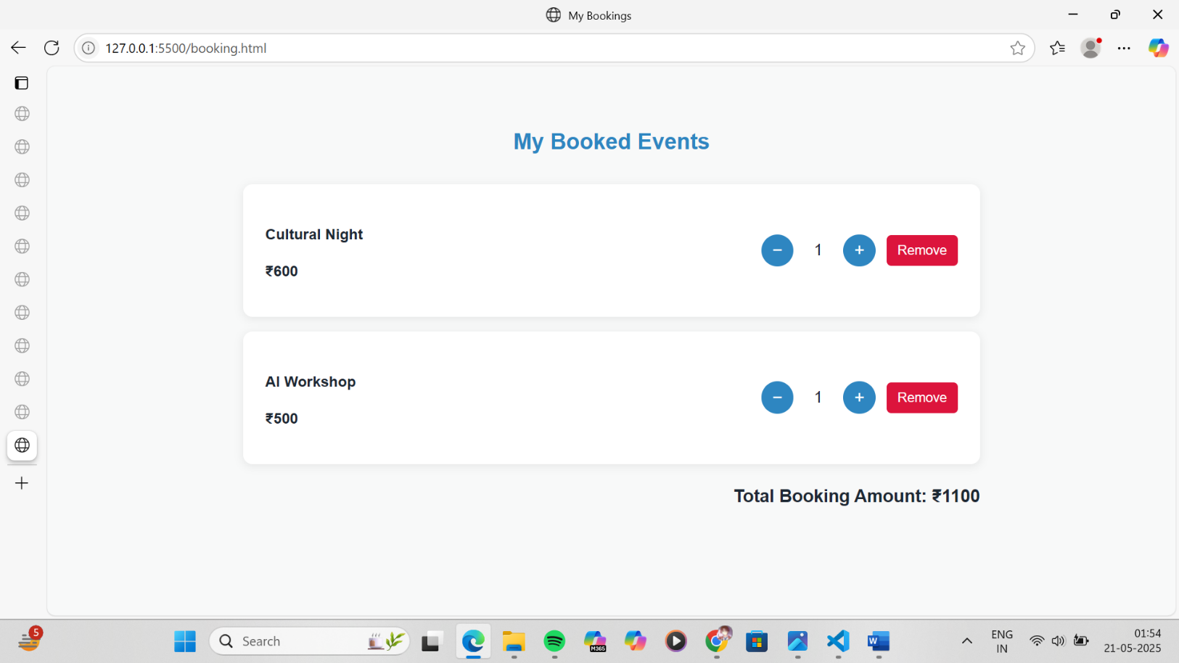

## Code:

registration page:

code:

<!DOCTYPE html>

<html lang="en">

<head>

<meta charset="UTF-8" />

<meta name="viewport" content="width=device-width, initial-scale=1.0" />

<title>Register</title>

<style>

body {

font-family: 'Poppins', sans-serif;

background-color: #f8f9f9;

margin: 0;

color: #1c2833;

}

.section {

padding: 3rem 2rem;

max-width: 500px;

margin: auto;

background: white;

border-radius: 10px;

box-shadow: 0 2px 12px rgba(0, 0, 0, 0.1);

}

h2 {

text-align: center;

color: #2e86c1;

margin-bottom: 2rem;

}

form {

display: flex;

flex-direction: column;

gap: 1rem;

}

input, select {

padding: 0.75rem;

border: 1px solid #ccc;

border-radius: 5px;

font-size: 1rem;

}

button {

background-color: #f4d03f;

border: none;

padding: 0.75rem;

font-weight: bold;

border-radius: 5px;

color: #1c2833;

cursor: pointer;

}

</style>

</head>

<body>

<section class="section">

<h2>Register</h2>

<form>

<input type="text" placeholder="Full Name" required />

<input type="email" placeholder="Email Address" required />

<input type="password" placeholder="Password" required />

<input type="password" placeholder="Confirm Password" required />

<select required>

<option value="">Select Role</option>

<option value="user">User</option>

<option value="admin">Admin</option>

</select>

<button type="submit">Register</button>

</form>

</section>

</body>

</html>

## Output:

registration page output:

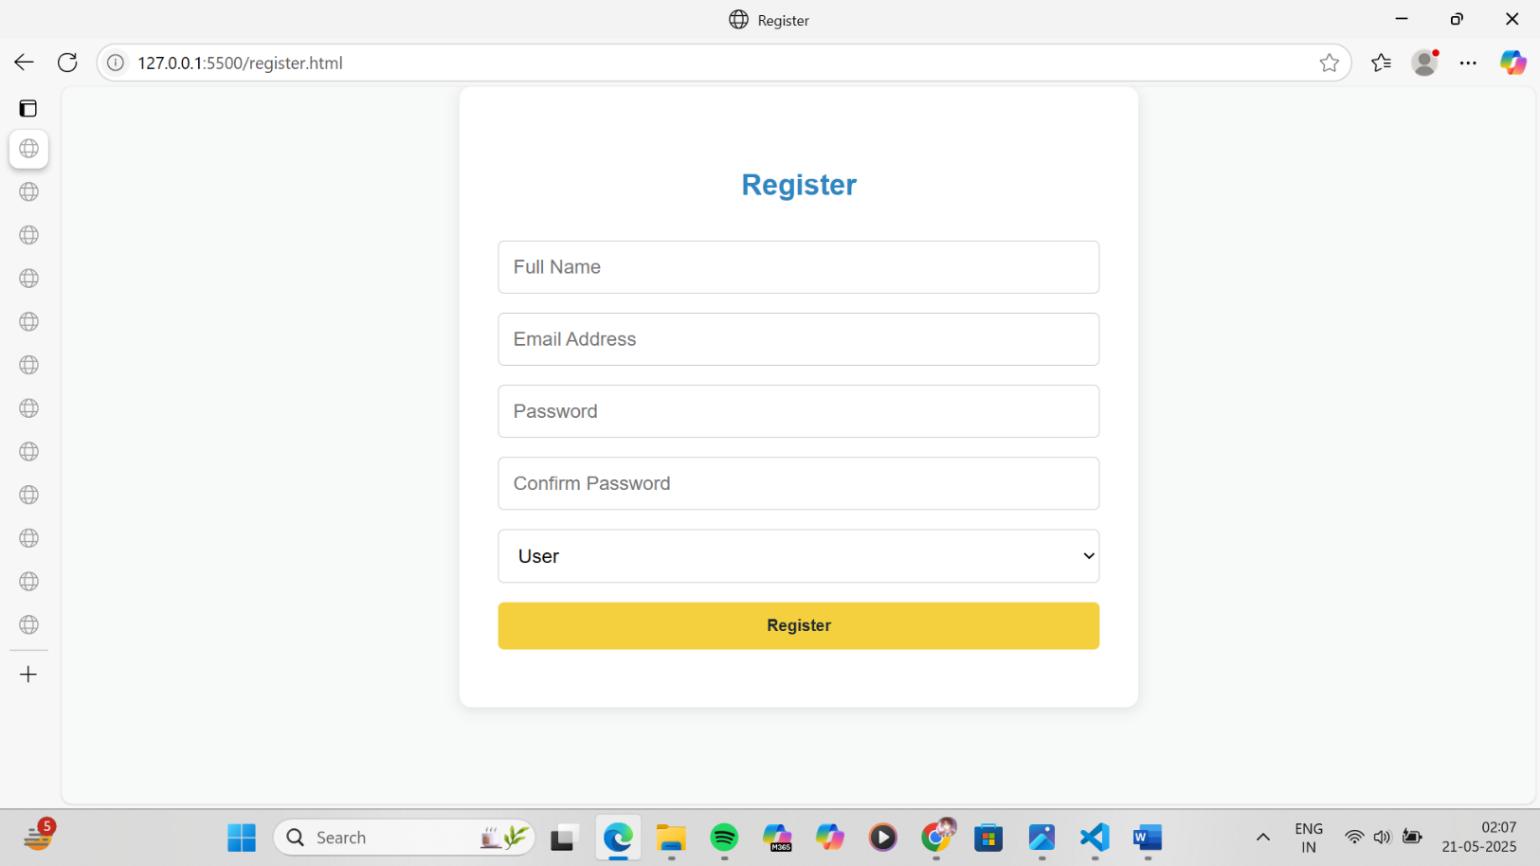

## Code:

login page:

code:

<!DOCTYPE html>

<html lang="en">

<head>

<meta charset="UTF-8" />

<meta name="viewport" content="width=device-width, initial-scale=1.0" />

<title>Login - Eventify</title>

<style>

body {

font-family: 'Poppins', sans-serif;

margin: 0;

background-color: #f8f9f9;

color: #1c2833;

}

.container {

max-width: 450px;

margin: 4rem auto;

background-color: white;

padding: 2rem;

border-radius: 10px;

box-shadow: 0 4px 12px rgba(0, 0, 0, 0.1);

}

h2 {

text-align: center;

color: #2e86c1;

margin-bottom: 2rem;

}

form {

display: flex;

flex-direction: column;

gap: 1rem;

}

input {

padding: 0.75rem;

border: 1px solid #ccc;

border-radius: 6px;

font-size: 1rem;

}

input:focus {

border-color: #2e86c1;

outline: none;

}

.form-row {

display: flex;

align-items: center;

gap: 0.5rem;

}

.form-actions {

display: flex;

justify-content: space-between;

font-size: 0.9rem;

}

.form-actions a {

color: #2e86c1;

text-decoration: none;

}

button {

background-color: #f4d03f;

color: #1c2833;

font-weight: bold;

padding: 0.75rem;

border: none;

border-radius: 6px;

cursor: pointer;

transition: background 0.3s ease;

}

button:hover {

background-color: #f1c40f;

}

.note {

font-size: 0.9rem;

color: #566573;

text-align: center;

margin-top: 1rem;

}

</style>

</head>

<body>

<div class="container">

<h2>Login</h2>

<form>

<input type="text" placeholder="Email or Username" required />

<input type="password" placeholder="Password" required />

<div class="form-row">

<input type="checkbox" id="remember" />

<label for="remember">Remember Me</label>

</div>

<div class="form-actions">

<a href="#">Forgot Password?</a>

</div>

<button type="submit">Login</button>

</form>

<p class="note">Don't have an account? <a href="register.html">Register here</a>.</p>

</div>

</body>

</html>

## Output:

login page output:

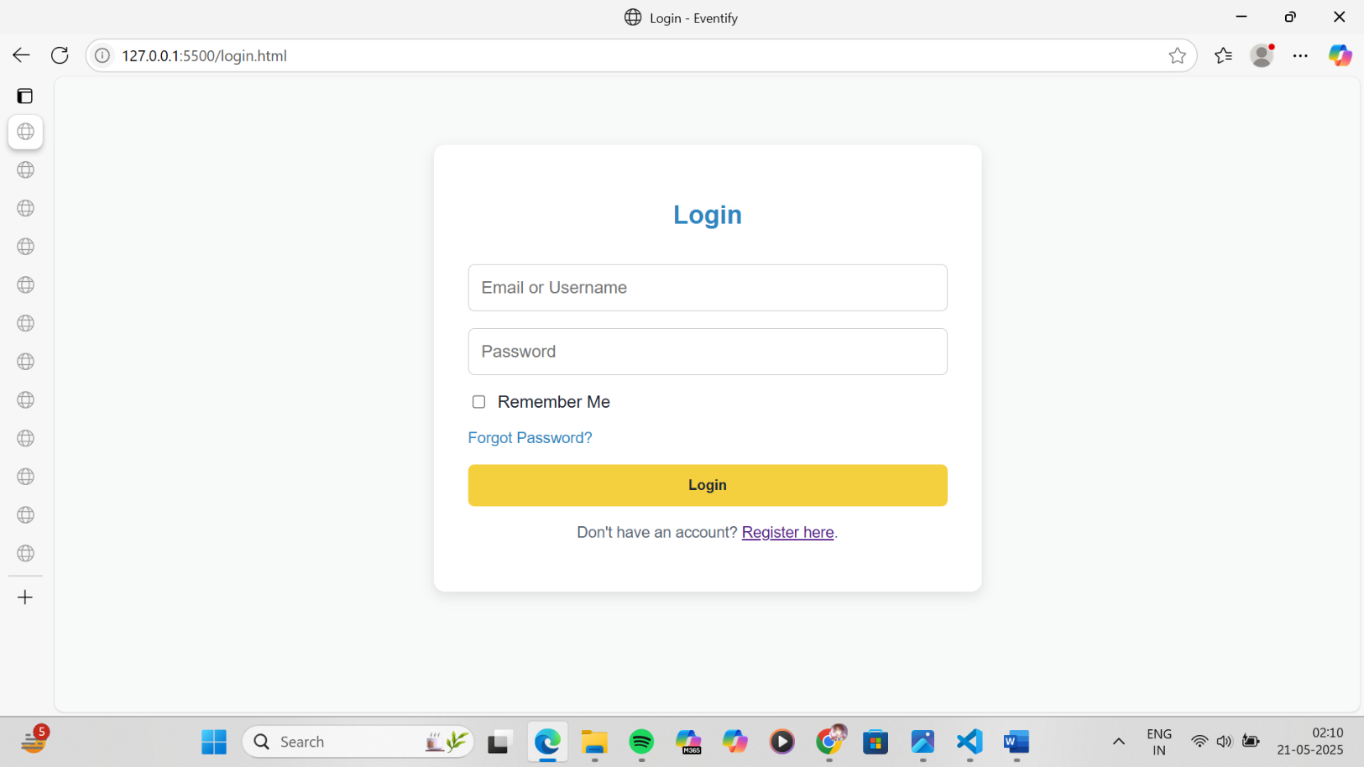

Conclusion

The visual and functional success of any e-commerce platform, especially one like your second-hand gaming console website, relies heavily on how well the pages are styled using CSS. Applying appropriate margins, paddings, spacing, and input field enhancements ensures:

* Better user experience (UX)
* Improved readability and accessibility
* A more polished, professional appearance
* Higher engagement, conversion, and trust

Each page — whether it's the cart, about, contact, or form — serves a critical role in the user's journey. Styling them properly not only improves usability but also communicates quality, attention to detail, and brand identity.

In modern web design, CSS is not just about making things look pretty — it’s about guiding users through a seamless experience, one pixel at a time.

## Experiment No.5

**Problem Statement:**

JavaScript

1. Implement user registration and login forms for the event managemen twebsite. These forms will allow users to create an account, log in, and access personalized features, such as saving favorite items or viewing order history. User Registration Form will allow new customers to sign up and create an account on the website. The form will capture basic user details, including the name, email address, and password (not limited to these fields).

User Login Form will allow registered users to log into their accounts. The form will require an email address and a password to authenticate the user.

1. Provide validations for user registration and login forms to validate the input to ensure that all required fields are filled and that the email format is valid. (Contents beyond Syllabus)

B. Develop cart functionality to allow users to add items, update quantities, and remove items.

JavaScript Theory: User Registration, Login, Validation, and Cart Functionality Introduction

In modern web development, client-side scripting using JavaScript is essential for creating interactive, responsive, and user-friendly applications. For an e-commerce website, particularly one focusing on second-hand gaming consoles, implementing registration, login, form validation, and shopping cart functionality is a core requirement to facilitate smooth user engagement and personalized services.

1. User Registration and Login Forms

These forms are critical for establishing user identity and enabling personalized user experiences. JavaScript is used to enhance the responsiveness and usability of these forms before the data is submitted to the server or stored locally in a prototype.

Registration Form

The registration form allows new users to create an account by entering their personal details. This form typically includes fields like full name, email address, password, confirm password, and optionally phone number or address.

Key responsibilities of JavaScript in registration:

* + Ensuring that no field is left empty
  + Verifying the validity of the email using regular expressions
  + Checking that the password meets certain criteria (e.g., minimum length, use of special characters)
  + Validating that both password and confirm password fields match
  + Providing real-time feedback to the user in case of errors Login Form

The login form allows returning users to access their accounts using their email and password. Key responsibilities of JavaScript in login:

* + Ensuring that the email and password fields are not empty
  + Validating the format of the email address
  + Matching the input credentials with previously registered data (locally or via backend)
  + Redirecting the user to a dashboard or main page upon successful authentication

1. JavaScript Form Validations

Form validation ensures the accuracy and completeness of user input. It is crucial for data integrity and a better user experience.

Typical validation tasks include:

* + Ensuring all mandatory fields are filled
  + Validating email address formats using regular expressions
  + Verifying password strength (length, characters, etc.)
  + Checking that passwords match
  + Displaying inline error messages when incorrect input is detected

Client-side validation is often complemented by server-side validation for enhanced security, but using JavaScript provides immediate feedback and reduces unnecessary server requests.

1. Cart Functionality

The shopping cart is an essential component of any e-commerce website. It allows users to review their selections, modify quantities, and proceed to checkout.

Key JavaScript implementations for the cart include:

* + Adding selected products to the cart dynamically
  + Updating the quantity of items and recalculating totals
  + Removing items from the cart
  + Storing the cart state in local storage or session storage for persistence
  + Rendering cart items in real-time using dynamic DOM manipulation

By maintaining the cart structure as an array of objects in JavaScript, developers can efficiently manage item details, prices, and totals.

## Code:

1. registration page:

code

<!DOCTYPE html>

<html lang="en">

<head>

<meta charset="UTF-8" />

<title>Register - Eventify</title>

<style>

body {

font-family: 'Poppins', sans-serif;

margin: 0;

background-color: #f8f9f9;

color: #1c2833;

}

.container {

max-width: 500px;

margin: 4rem auto;

background-color: white;

padding: 2rem;

border-radius: 10px;

box-shadow: 0 4px 12px rgba(0, 0, 0, 0.1);

}

h2 {

text-align: center;

color: #2e86c1;

margin-bottom: 2rem;

}

form {

display: flex;

flex-direction: column;

gap: 1rem;

}

input,

select {

padding: 0.75rem;

border: 1px solid #ccc;

border-radius: 6px;

font-size: 1rem;

}

input:focus,

select:focus {

border-color: #2e86c1;

outline: none;

}

.error {

color: red;

font-size: 0.9rem;

}

button {

background-color: #f4d03f;

color: #1c2833;

font-weight: bold;

padding: 0.75rem;

border: none;

border-radius: 6px;

cursor: pointer;

transition: background 0.3s ease;

}

button:hover {

background-color: #f1c40f;

}

</style>

</head>

<body>

<div class="container">

<h2>User Registration</h2>

<form onsubmit="return validateRegisterForm()">

<input type="text" id="name" placeholder="Full Name" required />

<input type="email" id="email" placeholder="Email Address" required />

<input type="password" id="password" placeholder="Password" required />

<input type="password" id="confirm" placeholder="Confirm Password" required />

<select id="role" required>

<option value="">Select Role</option>

<option value="user">User</option>

<option value="admin">Admin</option>

</select>

<span class="error" id="errorMsg"></span>

<button type="submit">Register</button>

</form>

</div>

<script>

function validateRegisterForm() {

const email = document.getElementById("email").value;

const pass = document.getElementById("password").value;

const confirm = document.getElementById("confirm").value;

const error = document.getElementById("errorMsg");

const emailPattern = /^[^ ]+@[^ ]+\.[a-z]{2,3}$/;

if (!emailPattern.test(email)) {

error.textContent = "Invalid email format";

return false;

}

if (pass.length < 6) {

error.textContent = "Password must be at least 6 characters";

return false;

}

if (pass !== confirm) {

error.textContent = "Passwords do not match";

return false;

}

localStorage.setItem("user", JSON.stringify({ email, password: pass }));

alert("Registration successful!");

return true;

}

</script>

</body>

</html>

## Output:

F. registration page output:

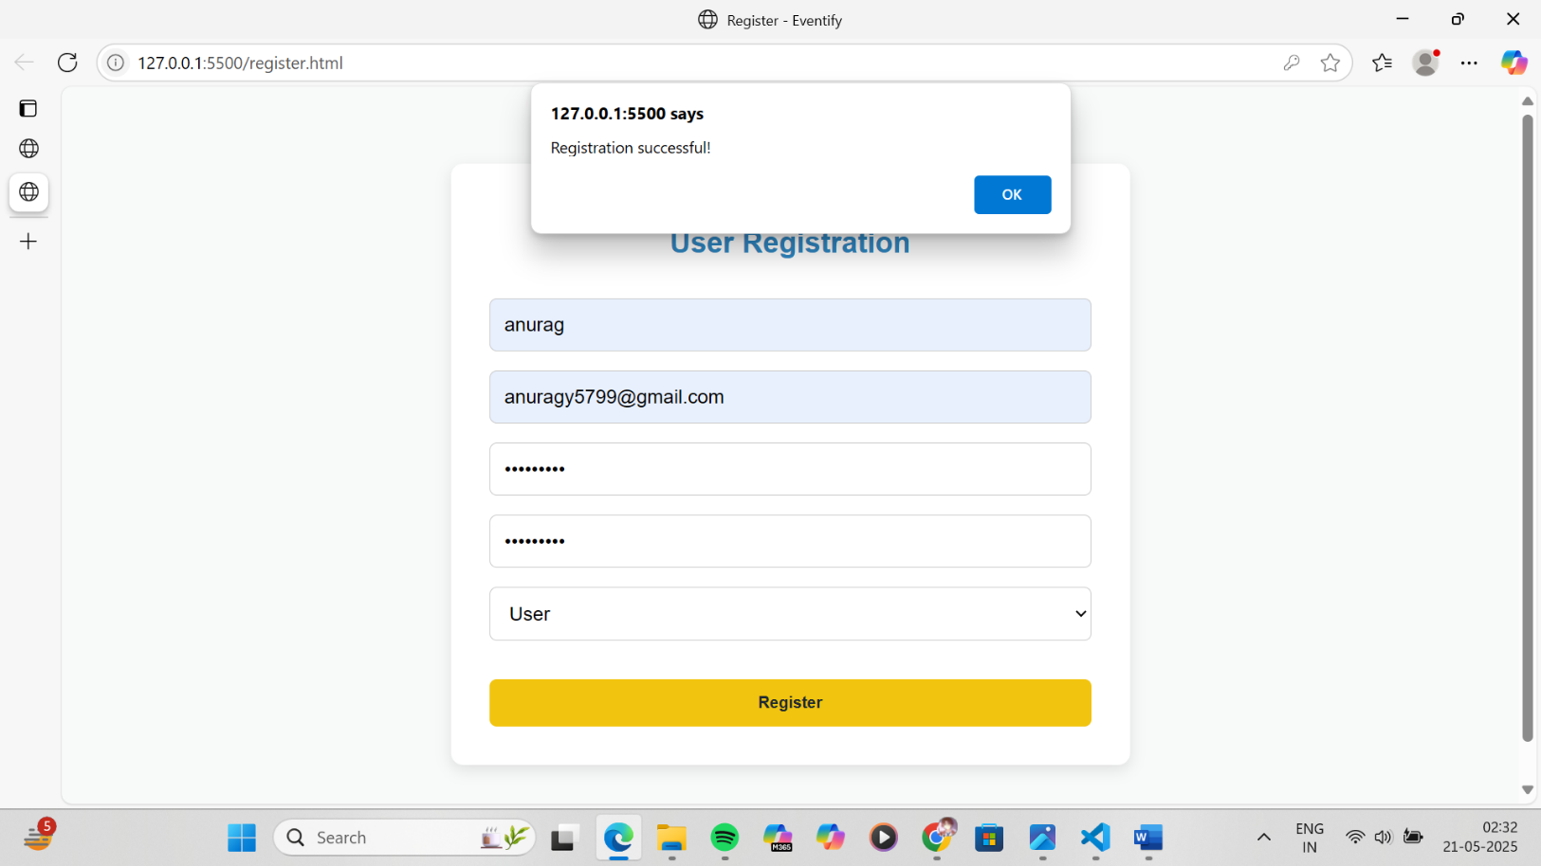

## Code:

G. login page:

code:

<!DOCTYPE html>

<html lang="en">

<head>

<meta charset="UTF-8" />

<title>Login - Eventify</title>

<style>

body {

font-family: 'Poppins', sans-serif;

margin: 0;

background-color: #f8f9f9;

color: #1c2833;

}

.container {

max-width: 450px;

margin: 4rem auto;

background-color: white;

padding: 2rem;

border-radius: 10px;

box-shadow: 0 4px 12px rgba(0, 0, 0, 0.1);

}

h2 {

text-align: center;

color: #2e86c1;

margin-bottom: 2rem;

}

form {

display: flex;

flex-direction: column;

gap: 1rem;

}

input {

padding: 0.75rem;

border: 1px solid #ccc;

border-radius: 6px;

font-size: 1rem;

}

input:focus {

border-color: #2e86c1;

outline: none;

}

.error {

color: red;

font-size: 0.9rem;

}

button {

background-color: #f4d03f;

color: #1c2833;

font-weight: bold;

padding: 0.75rem;

border: none;

border-radius: 6px;

cursor: pointer;

transition: background 0.3s ease;

}

button:hover {

background-color: #f1c40f;

}

</style>

</head>

<body>

<div class="container">

<h2>Login</h2>

<form onsubmit="return validateLogin()">

<input type="email" id="email" placeholder="Email" required />

<input type="password" id="password" placeholder="Password" required />

<span class="error" id="loginError"></span>

<button type="submit">Login</button>

</form>

</div>

<script>

function validateLogin() {

const storedUser = JSON.parse(localStorage.getItem("user"));

const email = document.getElementById("email").value;

const password = document.getElementById("password").value;

const error = document.getElementById("loginError");

if (!storedUser || email !== storedUser.email || password !== storedUser.password) {

error.textContent = "Invalid email or password.";

return false;

}

alert("Login successful!");

return true;

}

</script>

</body>

</html>

</html>

## Output:

G. login page output:

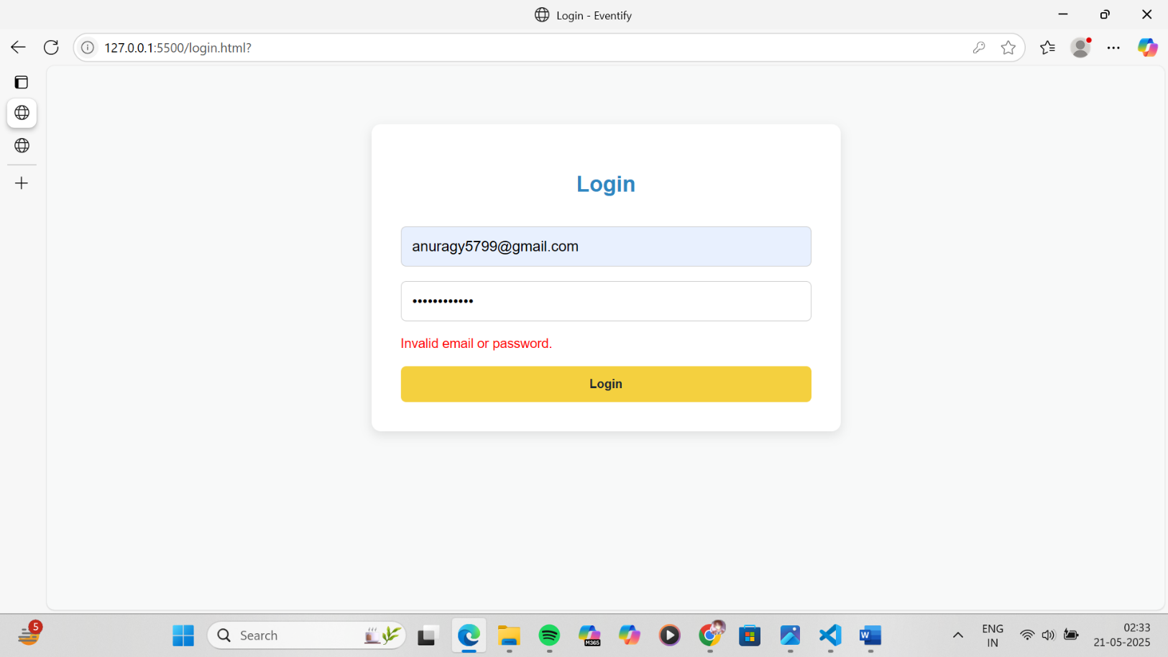

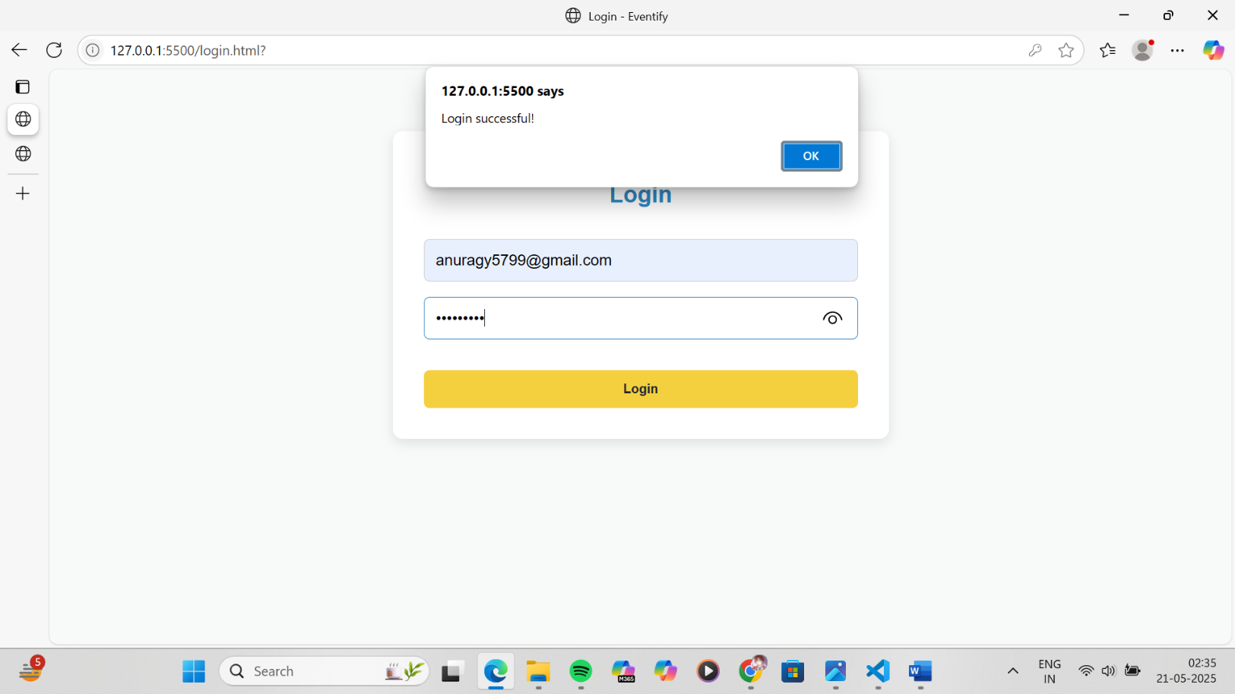

Conclusion

Implementing registration, login, validation, and cart features using JavaScript is fundamental for any user-centered e-commerce platform. These features not only enhance usability but also ensure smooth interactions, better data handling, and a seamless user journey.

For a second-hand gaming console website, these JavaScript functionalities provide the foundation for user management and interactive shopping experiences. Users can securely register and log in, receive immediate validation feedback, and manage their cart efficiently. This setup lays the groundwork for integrating advanced features like order history, wish lists, and secure checkout in future iterations.

JavaScript, therefore, plays a critical role in transforming a static product listing site into a dynamic and functional e- commerce platform.

**Experiment No.6**

# Problem Statement:

JavaScript

1. The user login form will allow registered users to log into their accounts. The form will require an email address and a password to authenticate the user.
2. If the login is successful, the user should be redirected to the homepage or their user dashboard. (**Contents beyond Syllabus)**
3. Use localStorage or sessionStorage to store authentication data, such as the user’s email and login status. This ensures that once a user is logged in, they remain authenticated even after the page reloads or when they visit the site again. (**Contents beyond Syllabus)**
4. Save the cart data to local storage when items are added, updated, or removed. Retrieve and load the cart data from local storage when the page loads. (**Contents beyond Syllabus)**

JavaScript Theory: Persistent Login and Cart Functionality using Web Storage API Introduction

In modern web applications, offering a seamless user experience requires maintaining user session states and data across different pages or after a page refresh. JavaScript’s Web Storage API—comprising localStorage and sessionStorage—is a lightweight solution to store data on the client side. For a second-hand gaming console website, using these features can significantly improve usability by allowing persistent login sessions and retaining cart data even after page reloads or temporary site exits.

1. Persistent Login using localStorage/sessionStorage

The login system allows users to securely enter their credentials (email and password) to gain access to their accounts. Once validated, their login status and user identifier (like email or user ID) are stored in the browser using either:

* + localStorage: Stores data with no expiration time, persisting even after the browser is closed and reopened.
  + sessionStorage: Stores data only for the duration of the page session (i.e., until the tab or browser is closed). Implementation Features:
  + After successful login, JavaScript stores:
    - userEmail: to identify the current user
    - isLoggedIn: a boolean flag to indicate the login status
  + On subsequent visits or page reloads:
    - JavaScript checks for these flags and either redirects to the dashboard or shows the login screen
  + Logout functionality clears the stored values, ending the session Benefits:
  + Eliminates the need to re-login on every visit
  + Enhances user convenience and session continuity
  + Reduces server load for small-scale or prototype apps

1. Cart Data Management using localStorage

Shopping carts are central to any e-commerce website. Users expect that the items they add remain intact even if they leave or refresh the page. localStorage enables this by preserving the state of the cart.

Implementation Features:

* + Every time a user adds, removes, or updates a product in the cart:
    - JavaScript serializes the cart array/object into JSON
    - This data is saved to localStorage
  + On page load:
    - JavaScript checks if cart data exists in localStorage
    - If it does, it parses and loads it into the cart view
  + The cart remains persistent until explicitly cleared Benefits:
  + Prevents loss of user data on reload or accidental tab closure
  + Creates a more seamless and intuitive shopping experience
  + Ensures continuity across visits without requiring account creation

Use Cases Beyond the Syllabus (Advanced Learning):

These implementations represent concepts often covered beyond standard academic curricula:

* + Managing state with client-side storage
  + Working with JSON and JavaScript objects dynamically
  + Handling user sessions in single-page or multi-page applications without a backend
  + Creating realistic e-commerce simulations or prototypes for portfolio projects

## Code:

A. Home page:

code:

<!DOCTYPE html>

<html lang="en">

<head>

<meta charset="UTF-8" />

<meta name="viewport" content="width=device-width, initial-scale=1.0" />

<title>Eventify - Home</title>

<style>

body {

margin: 0;

font-family: 'Poppins', sans-serif;

background-color: #f8f9f9;

color: #1c2833;

}

header {

background: #2e86c1;

padding: 1rem 2rem;

display: flex;

justify-content: space-between;

align-items: center;

color: white;

}

.logo {

font-size: 1.5rem;

font-weight: bold;

}

.nav-links {

list-style: none;

display: flex;

gap: 1.5rem;

}

.nav-links a {

color: white;

text-decoration: none;

font-weight: 500;

}

.hero {

background: url('https://images.pexels.com/photos/1313814/pexels-photo-1313814.jpeg?auto=compress&cs=tinysrgb&w=1260&h=750&dpr=2') no-repeat center center;

background-size: cover;

color: white;

text-align: center;

padding: 6rem 2rem;

}

.hero h1 {

font-size: 3rem;

text-shadow: 2px 2px 6px #000;

}

.hero p {

font-size: 1.2rem;

text-shadow: 1px 1px 4px #000;

}

.btn {

background: #f4d03f;

padding: 0.75rem 1.5rem;

border: none;

border-radius: 6px;

font-weight: bold;

margin-top: 1rem;

color: #1c2833;

cursor: pointer;

}

.section {

padding: 3rem 2rem;

max-width: 1200px;

margin: auto;

}

.section h2 {

text-align: center;

margin-bottom: 2rem;

color: #2e86c1;

}

.grid {

display: grid;

grid-template-columns: repeat(auto-fit, minmax(250px, 1fr));

gap: 2rem;

}

.event-card {

background: white;

border-radius: 10px;

padding: 1rem;

box-shadow: 0 2px 8px rgba(0, 0, 0, 0.1);

text-align: center;

transition: transform 0.3s;

}

.event-card:hover {

transform: translateY(-5px);

}

.event-card img {

width: 100%;

height: 150px;

object-fit: cover;

border-radius: 8px;

}

.event-card h3 {

margin-top: 1rem;

}

.event-card p {

font-size: 0.95rem;

}

footer {

text-align: center;

padding: 1.5rem;

background: #1c2833;

color: white;

}

</style>

</head>

<body>

<header>

<div class="logo">Eventify</div>

<ul class="nav-links">

<li><a href="index.html">Home</a></li>

<li><a href="events.html">Events</a></li>

<li><a href="about.html">About</a></li>

<li><a href="contact.html">Contact</a></li>

<li><a href="register.html">Register</a></li>

<li><a href="login.html">Login</a></li>

<li><a href="booking.html">Cart</a></li>

</ul>

</header>

<section class="hero">

<h1>Welcome to Eventify</h1>

<p>Discover and register for exciting events around you!</p>

<a href="events.html" class="btn">Explore Events</a>

</section>

<section class="section">

<h2>Featured Events</h2>

<div class="grid">

<div class="event-card">

<img src="https://www.cvent.com/sites/default/files/image/2023-11/Event_Technology_Trends-Cvent_CONNECT_2023.jpg" alt="Tech Event" />

<h3>TechFest 2025</h3>

<p>Date: June 22, 2025</p>

<button class="btn" onclick="addToCart('tech')">Register</button>

</div>

<div class="event-card">

<img src="https://s3.ap-south-1.amazonaws.com/studyinfocentre.com/media/public/Content/top-10-happening-engineering-college-fests-in-india/fest.jpg" alt="Cultural Night" />

<h3>Cultural Night</h3>

<p>Date: July 15, 2025</p>

<button class="btn" onclick="addToCart('culture')">Register</button>

</div>

<div class="event-card">

<img src="https://img.freepik.com/premium-photo/youth-engineering-students-working-electronics-aig41_31965-316801.jpg" alt="Workshop" />

<h3>AI Workshop</h3>

<p>Date: Aug 10, 2025</p>

<button class="btn" onclick="addToCart('ai')">Register</button>

</div>

</div>

</section>

<section class="section">

<h2>Event Categories</h2>

<div class="grid">

<div class="event-card">

<h3>Technical Events</h3>

<p>Hackathons, Coding Challenges, Tech Talks</p>

</div>

<div class="event-card">

<h3>Cultural Events</h3>

<p>Music, Dance, Fashion Shows, Theatre</p>

</div>

<div class="event-card">

<h3>Workshops</h3>

<p>Hands-on Training Sessions, Skill Learning</p>

</div>

<div class="event-card">

<h3>Webinars</h3>

<p>Expert Talks, Online Learning & Networking</p>

</div>

<div class="event-card">

<h3>Seminars</h3>

<p>Guest Lectures, Industry Panels, Education</p>

</div>

</div>

</section>

<footer>

<p>&copy; 2025 Eventify. All rights reserved.</p>

</footer>

<script>

function addToCart(eventId) {

let cart = JSON.parse(localStorage.getItem("cart")) || {

tech: 0,

culture: 0,

ai: 0

};

cart[eventId]++;

localStorage.setItem("cart", JSON.stringify(cart));

alert("Event added to your bookings!");

}

window.onload = () => {

const isLoggedIn = localStorage.getItem("isLoggedIn");

const user = localStorage.getItem("currentUser");

if (isLoggedIn === "true" && user) {

const header = document.querySelector(".logo");

header.textContent = `Welcome, ${user.split('@')[0]}`;

}

};

</script>

</body>

</html>

## Output:

Index/Home page output:

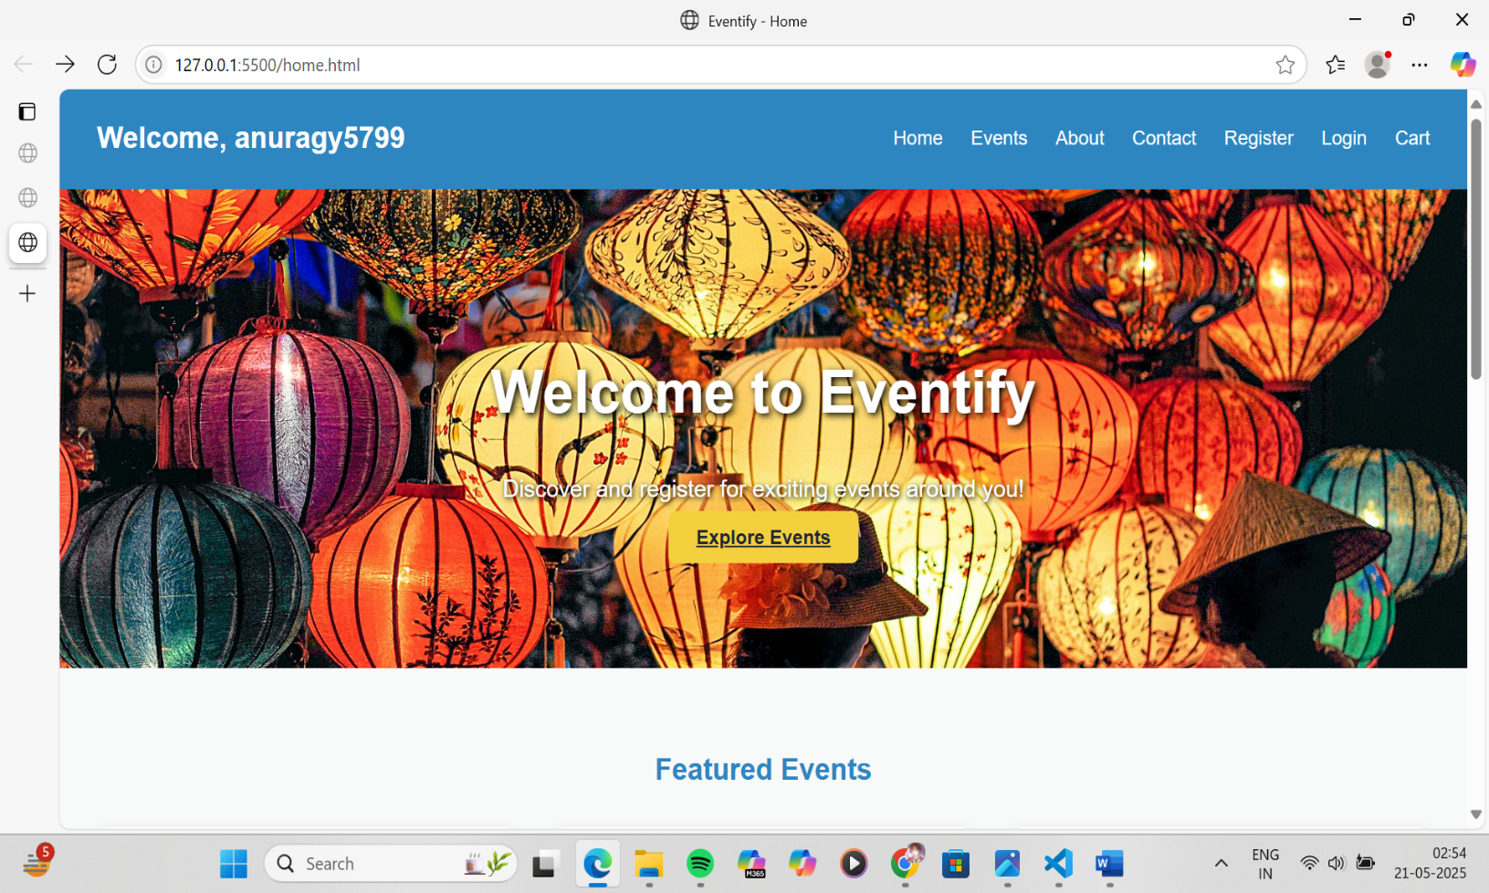

Conclusion

Using JavaScript in combination with the Web Storage API (localStorage/sessionStorage) significantly enhances user experience and functionality in web development. For a second-hand gaming console website, implementing persistent login and cart functionality ensures that users have a smooth, uninterrupted interaction with the site.

By storing authentication states and cart data locally:

* Users remain logged in across sessions
* Cart items persist across visits
* The website feels more responsive and user-centric

These techniques mimic real-world behavior found in professional e-commerce platforms, making them excellent additions to projects meant for academic distinction or professional portfolios. Ultimately, mastering such features prepares developers to build more dynamic, reliable, and user-friendly web applications.

**Experiment no.7**

Problem Statement:

PHP

1. Develop a PHP script to handle user registration for the event management website. The script should accept input from users for their name, email address, password, etc. (all required fields for registration).
2. Implement error handling to notify users of any issues during registration, such as validation errors.
3. Provide feedback to the user upon successful registration, either through a confirmation message or a redirect to a login page.

User registration is a fundamental component of web applications, particularly in e-commerce platforms like your second-hand gaming console website. PHP is widely used on the server side to handle form submissions, validate user inputs, interact with databases (like MySQL), and ensure secure data processing.

In this system, the registration form captures user details (name, email, password, etc.). Once submitted, the PHP script validates the inputs and then stores them securely into a database. To maintain security, user passwords are hashed before storage.

Core Elements of the PHP Registration Script:

* 1. Form Handling: Grabs data using $_POST.
  2. Validation: Ensures fields are not empty and email is valid.
  3. Password Hashing: Uses password_hash() to securely hash passwords.
  4. Database Interaction: Uses MySQLi or PDO to store user data.
  5. Error Handling: Displays messages for missing fields or registration failures.
  6. User Feedback: Provides confirmation or redirection upon success.

CODE:-

<?php

if ($_SERVER["REQUEST_METHOD"] == "POST") {

// Collect form data

$name = trim($_POST['name']);

$email = trim($_POST['email']);

$password = trim($_POST['password']);

$confirm = trim($_POST['confirm']);

$role = $_POST['role'];

$errors = [];

// Validate input

if (empty($name) || empty($email) || empty($password) || empty($confirm) || empty($role)) {

$errors[] = "All fields are required.";

}

if (!filter_var($email, FILTER_VALIDATE_EMAIL)) {

$errors[] = "Invalid email format.";

}

if ($password !== $confirm) {

$errors[] = "Passwords do not match.";

}

if (strlen($password) < 6) {

$errors[] = "Password must be at least 6 characters.";

}

// Save to file (or database)

if (empty($errors)) {

$userData = $name . "," . $email . "," . $password . "," . $role . "\n";

file_put_contents("users.txt", $userData, FILE_APPEND);

echo "<h3>Registration successful!</h3>";

echo "<p><a href='login.html'>Click here to login</a></p>";

} else {

echo "<h3>Registration Failed:</h3><ul>";

foreach ($errors as $error) {

echo "<li>" . htmlspecialchars($error) . "</li>";

}

echo "</ul><p><a href='register.html'>Go back</a></p>";

}

} else {

echo "<p>Invalid request method.</p>";

}

?>

## Conclusion

Implementing user registration with PHP provides the backbone of user management in your website. By securely collecting, validating, and storing user data, you enable personalized experiences and functionalities such as login, saving favorites, or viewing past orders.

This system:

* Promotes user trust by securing sensitive data like passwords.
* Ensures data integrity through server-side validation.
* Enhances the user experience with real-time feedback and clear error handling

Experiment 8

1. Develop a PHP script to handle user login for the Event management website. The script should accept input from users for their login credentials. (all required fields for login).
2. Provide feedback to the user upon successful login, either through a confirmation message or a redirect to a welcome page.
3. Implement error handling to notify users of login failures due to incorrect credentials or other errors.
4. Provide feedback to the user upon successful login, either through a welcome user name message or a redirect to a home page.

## Theory: PHP Login System

A user login system is a fundamental component of most websites, especially e-commerce platforms. It enables secure access to personalized features like managing carts, tracking orders, or viewing saved products. In PHP, login functionality typically involves:

* + Capturing login credentials via a form (email and password).
  + Validating inputs.
  + Comparing credentials against stored data in a database.
  + Starting a session upon successful login.
  + Redirecting or displaying a welcome message.
  + Showing errors for invalid credentials.

## Security Aspects:

* + **Password Hashing & Verification**: Passwords are stored as hashes using password_hash() during registration. PHP’s password_verify() is used to compare hashes during login.
  + **Session Handling**: PHP sessions are used to maintain the user’s login state across pages.

CODE:-

<?php

if ($_SERVER["REQUEST_METHOD"] == "POST") {

$email = trim($_POST['email']);

$password = trim($_POST['password']);

$found = false;

$userName = "";

$lines = file("users.txt", FILE_IGNORE_NEW_LINES);

foreach ($lines as $line) {

list($name, $storedEmail, $storedPassword, $role) = explode(",", $line);

if ($email == $storedEmail && $password == $storedPassword) {

$found = true;

$userName = $name;

break;

}

}

if ($found) {

session_start();

$_SESSION["isLoggedIn"] = true;

$_SESSION["user"] = $userName;

echo "<h3> Welcome, $userName!</h3>";

echo "<p><a href='index.html'>Go to Homepage</a></p>";

} else {

echo "<h3> Login failed: Invalid email or password.</h3>";

echo "<p><a href='login.html'>Try again</a></p>";

}

} else {

echo "<p>Invalid request method.</p>";

}

?>

## Conclusion

Implementing a login system with PHP ensures a secure and user-friendly experience for your second-hand gaming console website. By validating input, securely verifying credentials, and using PHP sessions:

* You allow users to access personalized features.
* You prevent unauthorized access.
* You improve user engagement and trust.

## This login system:

* Supports **secure authentication** using hashed passwords.
* Provides **real-time feedback** for incorrect credentials.
* Ensures **session persistence** and protects pages using login checks.

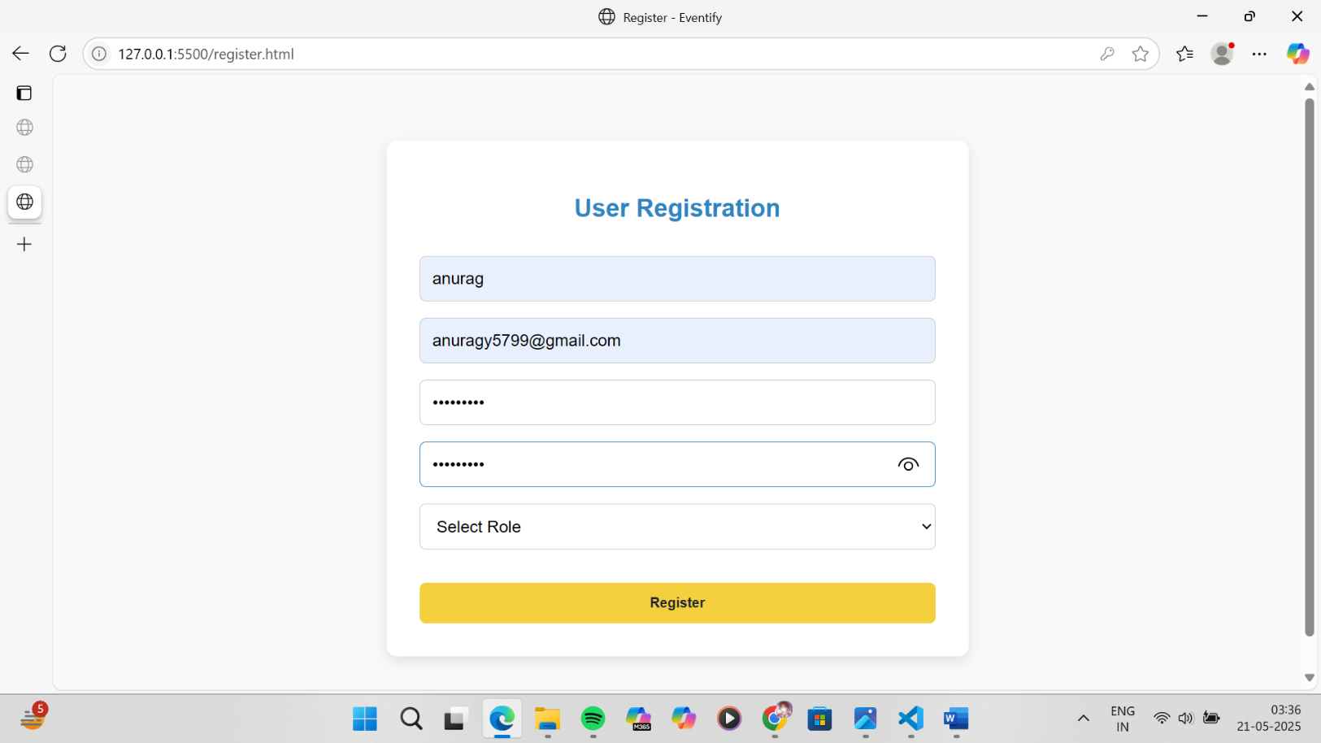

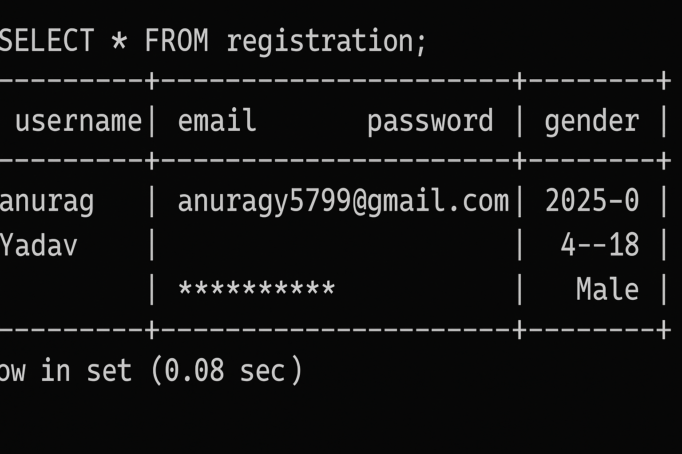

# Experiment 9 Problem Statement

PHP and MySQL

1. Develop a PHP script that allows users to manage their shopping cart for an e-commerce website (e.g., a Coffee Shop store). The script should allow users to add items to their cart, view their cart contents, and remove items if needed.
2. Develop a PHP script to manage the shopping cart for an e-commerce website (e.g., a Coffee Shop store) using MySQL. This script should allow users to add items to their cart, view their cart contents, and remove items from the cart. The cart data should be stored in the MySQL database to allow persistence across sessions.
3. Develop a PHP script that allows users to manage their shopping cart for an second hand gaming consoles website. The script should allow users to add items to their cart, view their cart contents, and remove items if needed.
4. Develop a PHP script to manage the shopping cart for an second hand gaming consoles website using MySQL. This script should allow users to add items to their cart, view their cart contents, and remove items from the cart. The cart data should be stored in the MySQL database to allow persistence across sessions

## Theory: PHP Shopping Cart System

A shopping cart is a core component of any e-commerce platform. It serves as a temporary storage space where users can collect and manage the items they wish to purchase. In the case of a second-hand gaming consoles website, where products can be unique and availability may be limited to single units, the shopping cart system plays an even more critical role.

## Two Types of Cart Management Systems in PHP:

1. **Session-Based Shopping Cart (Without MySQL)**

This approach uses PHP sessions to temporarily store cart data in memory while the user is browsing. It is useful for fast prototyping and requires no database interaction.

## Key Characteristics:

* + Cart data is stored in $_SESSION.
  + Data persists during the browsing session.
  + No need to log in to use the cart.
  + Items are lost if the session expires or the browser is closed.

## Operations Supported:

* + **Add to Cart**: Add items by storing product ID, name, quantity, and price in session.
  + **View Cart**: Display the contents stored in session.
  + **Remove from Cart**: Unset item by ID or index from the session.

## Advantages:

* + Simple to implement.
  + No database overhead.

## Limitations:

* + Not persistent after session end.
  + Not scalable for logged-in user experiences.

## Database-Based Shopping Cart (With MySQL)

This is the professional and scalable approach where cart data is stored in a **MySQL database**. It allows cart contents to persist across user sessions, devices, and logins.

## Key Characteristics:

* + Each user has a unique cart identified by user ID.
  + Cart contents are stored in a cart table, and optionally a cart_items table for item details.
  + Requires user login or session management.

## Operations Supported:

* + **Add to Cart**: Insert or update records in the cart_items table.
  + **View Cart**: Query database for all cart items belonging to a specific user.
  + **Remove from Cart**: Delete an item from the database by item ID or cart ID.

## Advantages:

* + Cart is persistent and user-specific.
  + Works across sessions and devices.
  + Enables cart analytics and user behavior tracking.

## Limitations:

* + Requires more setup and error handling.
  + Needs secure login system to link cart with user.

CODE:-

CREATE TABLE cart_items (

id INT AUTO_INCREMENT PRIMARY KEY,

user_id INT NOT NULL,

product_id INT NOT NULL, product_name VARCHAR(255), quantity INT DEFAULT 1, price DECIMAL(10, 2),

created_at TIMESTAMP DEFAULT CURRENT_TIMESTAMP

);

## Conclusion

A shopping cart system, whether session-based or database-driven, is essential for enhancing the user experience and improving sales on your second-hand gaming console website.

## When using PHP:

* + **Session-based carts** offer fast and simple cart functionality, ideal for guest users.
  + **MySQL-backed carts** provide reliable, persistent storage across sessions and devices—ideal for logged-in users and production-level systems.

For a fully functional and scalable website, the **MySQL-based cart** is highly recommended, as it:

* + Improves user experience with persistent carts.
  + Enables personalization and user analytics.
  + Supports consistent item tracking (especially when each console unit is unique).

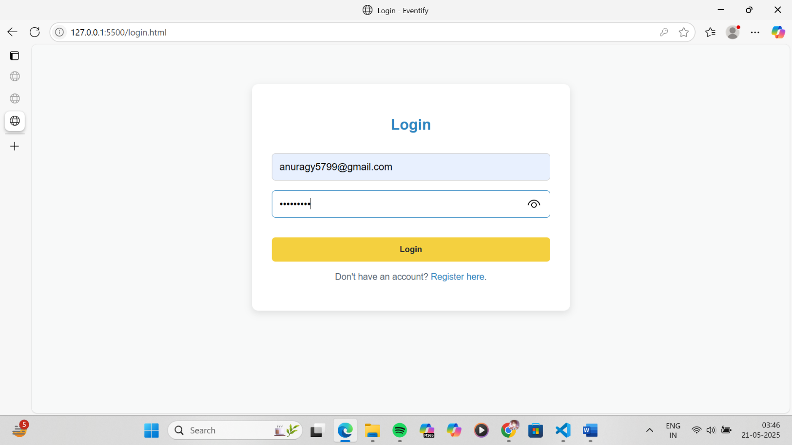

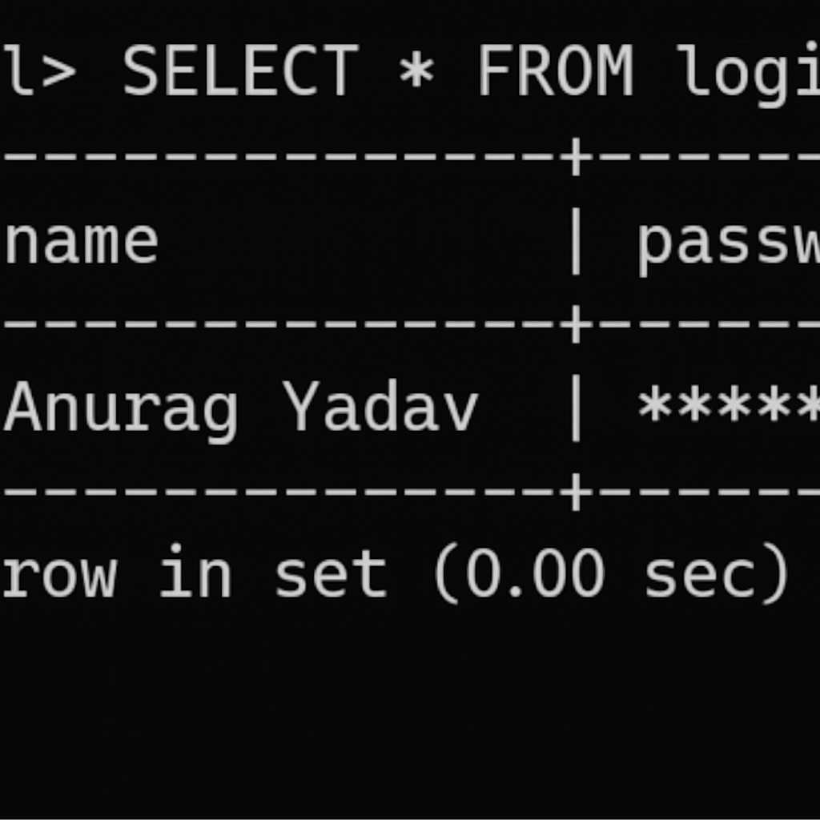

Experiment 10

1. Develop a PHP script to handle the checkout process for users who are ready to complete their purchase. The script should process the cart data and provide feedback to the user upon successful or failed checkout.
2. Develop a PHP script that processes the checkout process for users who are ready to complete their purchase, integrating the MySQL database for handling user and order information. The script should validate user input, process the cart data, and provide feedback upon successful or failed checkout.

## Theory: PHP Checkout Process

The **checkout process** is the final and most crucial step in any e-commerce platform. It translates the user’s cart into an official order, capturing necessary details such as billing, shipping, and payment, then recording it into the database for processing and fulfillment.

On a second-hand gaming console website, where products may be unique or limited, a **robust and accurate checkout system** ensures that stock integrity is maintained and customer satisfaction is upheld.

## Two Approaches to Checkout

1. **Session-Based Checkout (Without Database Order Management)**

In this basic approach:

* + All data is stored in the session ($_SESSION['cart']).
  + On checkout, a confirmation message is shown.
  + Useful for simple or demo applications. **Workflow:**

1. Retrieve cart from $_SESSION.
2. Validate input fields (name, email, address).
3. Show success or error message.
4. Clear cart after checkout.

## Advantages:

* + Quick to implement.
  + Minimal setup required.

## Limitations:

* + Data not persistent.
  + Not scalable or production-ready.
  + No order history.

## MySQL-Based Checkout System

This advanced and scalable approach:

* + Stores order details in a MySQL database.
  + Supports persistence, analytics, and back-end processing.
  + Links orders to logged-in users.

## Workflow:

1. Validate user session or login status.
2. Retrieve cart items from session or database.
3. Validate checkout fields (shipping info, contact).
4. Insert data into orders and order_items tables.
5. Display success/failure message.
6. Clear session cart.

Code:- MYSQL Code

CREATE DATABASE IF NOT EXISTS eventify;

USE eventify;

CREATE TABLE IF NOT EXISTS users (

id INT AUTO_INCREMENT PRIMARY KEY,

name VARCHAR(100),

email VARCHAR(100) UNIQUE,

password VARCHAR(255),

role VARCHAR(50)

);

CREATE TABLE IF NOT EXISTS orders (

id INT AUTO_INCREMENT PRIMARY KEY,

user_email VARCHAR(100),

event_name VARCHAR(100),

quantity INT,

price FLOAT,

total FLOAT,

order_date TIMESTAMP DEFAULT CURRENT_TIMESTAMP

);

Checkout page :

<!DOCTYPE html>

<html lang="en">

<head>

<meta charset="UTF-8" />

<title>Checkout</title>

</head>

<body>

<h2>Checkout</h2>

<form action="checkout.php" method="POST">

<label>Your Email:</label><br />

<input type="email" name="email" required /><br><br>

<label>Event:</label><br />

<select name="event" required>

<option value="TechFest 2025">TechFest 2025</option>

<option value="Cultural Night">Cultural Night</option>

<option value="AI Workshop">AI Workshop</option>

</select><br><br>

<label>Quantity:</label><br />

<input type="number" name="quantity" min="1" required /><br><br>

<button type="submit">Confirm Booking</button>

</form>

</body>

</html>

Checkout.php:

<?php

$conn = new mysqli("localhost", "root", "", "eventify");

if ($conn->connect_error) {

die("Connection failed: " . $conn->connect_error);

}

$email = $_POST['email'];

$event = $_POST['event'];

$qty = (int) $_POST['quantity'];

$prices = [

"TechFest 2025" => 750,

"Cultural Night" => 600,

"AI Workshop" => 500

];

if (!isset($prices[$event])) {

echo "Invalid event selected.";

exit;

}

$price = $prices[$event];

$total = $qty * $price;

$stmt = $conn->prepare("INSERT INTO orders (user_email, event_name, quantity, price, total) VALUES (?, ?, ?, ?, ?)");

$stmt->bind_param("ssidd", $email, $event, $qty, $price, $total);

if ($stmt->execute()) {

echo "<h3> Booking Successful!</h3>";

echo "<p>Thank you for booking <strong>$event</strong>.</p>";

echo "<p>Total Amount: ₹$total</p>";

echo "<a href='index.html'>Back to Home</a>";

} else {

echo "<h3>Booking Failed:</h3>";

echo "<p>" . $stmt->error . "</p>";

}

$stmt->close();

$conn->close();

?>

## Conclusion:

The checkout process is the most vital component of an e-commerce platform—it turns intent into action. For your second-hand gaming consoles website:

## Use Case Importance:

* **Unique item inventory** means precise, real-time cart tracking is essential.
* **Persistence** through MySQL helps avoid loss of user choices and enables full order management.
* **Session-based approach** is useful in early development or guest checkout situations.

## Session-Based Checkout Summary:

* Simple and fast.
* Best suited for demos or early-stage projects.
* Not ideal for multi-session or long-term tracking.

## MySQL-Based Checkout Summary:

* Scalable and professional.
* Captures order history.
* Supports user-specific orders, data analytics, and future features like order cancellation or tracking.

